**Project Profile**

|  |  |
| --- | --- |
| **Project Name:** | **Online Quiz System** |
| **Objective:** | **The online quiz system is to allows users to attempt quiz and automatically generates results based on answers marked by users.** |
| **Front End Tool:** | **PHP (5.5.12)** |
| **Back End Tool:** | **MySQL Server (5.6.17)** |
| **Other Tools:** | **Bracket , Notepad++** |
| **Platform of Application:** | **Web Application** |
| **Internal Project Guide:** | **Ms. Asha Patel** |
| **Time Duration:** | **90 days** |
| **Submitted To:** | **Department of Computer Science, GANPAT UNIVERSITY.** |

**EXISTING SYSTEM**

* There are lots of paper work at present.
* Answers are checked manually by the faculties.
* It is time consuming.
* It is time consuming to declare the result.
* It is hard to analyze the specific student performance.

**NEED FOR NEW SYSTEM**

* It will be an online quiz system.
* Work will get completed in short time period.
* Admin can manage the quiz.
* Admin can also easily check the performance of the student.
* Answer will check automatically by the system from the database.
* Result will display at the end of the paper directly.
* We can easily find student information anywhere and anytime from system.

|  |  |  |  |  |  |
| --- | --- | --- | --- | --- | --- |
| **SYSTEM NAME** | **TIMMING** | **OPTION** | **GEN /**  **STUDY** | **RESULT TIME** | **HINT** |
| Logo quiz | × | img | gen | × | √ |
| aptitude | × | √ | gen | Few hours | √ |
| quiz system | √ | √ | study | Any time | × |

**Functional Specification**

User Specification:

There are Three Users:

1. **Admin:** manage the overall system.
2. **Faculty:** add quiz, view History, update profile.
3. **Student:**  view History, attempt quiz etc.

Module Specification:

* **Login:** Admin, faculty and student login in this module.
* **Manage Faculty:** Admin can manage faculty.
* **Manage Course:** Admin can manage Course.
* **Manage Semester:** Admin can manage Semester.
* **Manage Subject:** Admin can manage Subject.
* **Manage Student:** Admin can manage Student.
* **Manage Faculty Permission:** Admin can manage the faculty permission.
* **Quiz:** Admin and Faculty can add or remove quiz , Student attempt quiz.
* **History :** Admin, faculty and student can view History.
* **Feedback:** admin and faculty view the feedback. Student can send the feedback.

**SYSTEM REQUIREMENT**

* **Minimum hardware requirement:-**

**Server side**

Processor : 2.0 Ghz

RAM : 2 GB

Free Hard Disk Spa : 20 GB

**Client side**

Processor : 1.0 Ghz

RAM : 1 GB

Free Hard Disk Spa : 10 GB

* **Minimum software requirement:-**

**Server side**

* Web server : Apache Web server(2.4.9)
* Front End : MYSQL Server(5.6.17)
* Back End : PHP(5.5.12)
* Operating system : Windows 7 or higher version

**Client side**

* Web browser : Chrome or any other compatible browser
* Operating system : Windows 7 or higher version

**SYSTEM FLOW DIAGRAM**

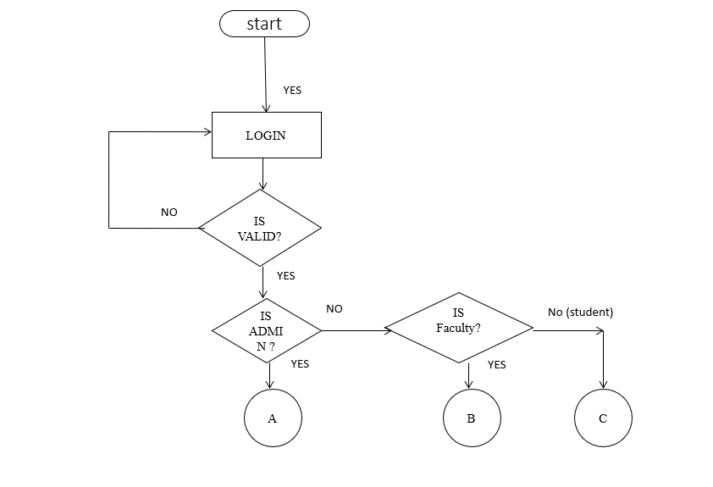

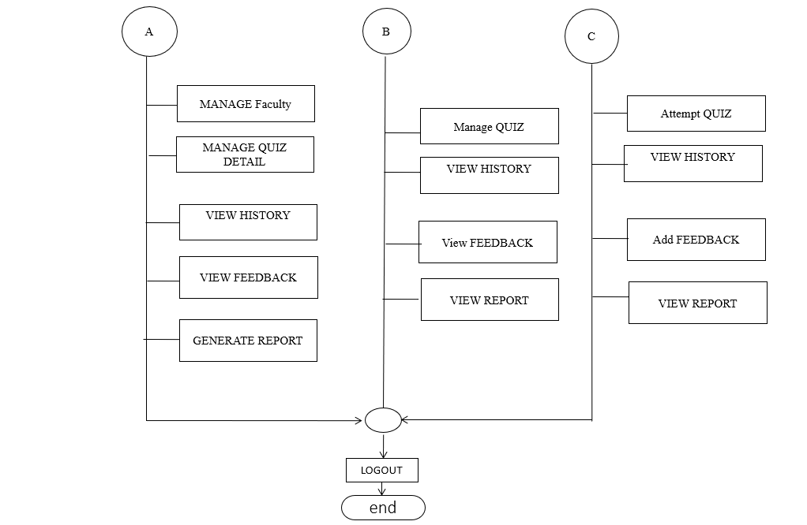

**E-R DIAGRAM**

VIEW

ADMIN

1

1

MANAGE

M M

STUDENT

FACULTY

1 1

1

VIEW

MANAGE

M

COURSE

M M

1M

HAS

FEEDBACK

QUESTION

M

SEM

M

1

HAS

CHOICE

M M

SUBJECT

1

HAS

M

HAS

M

SUB_QUIZ

FILL

**Data Flow Diagram**

* 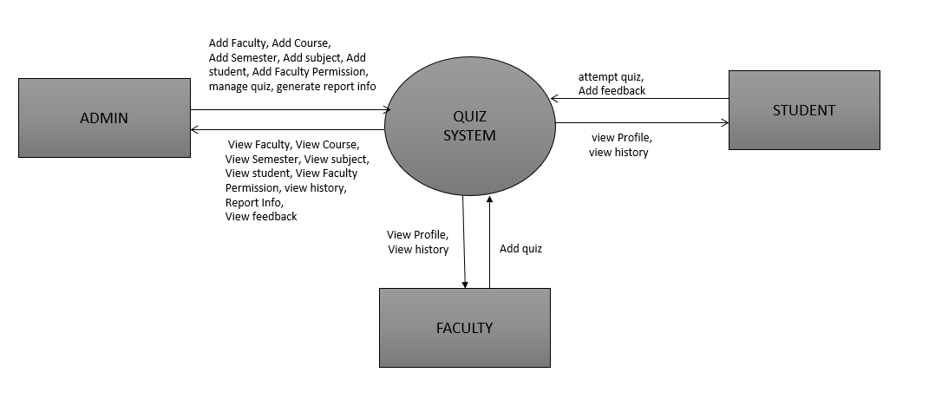**Context Level Diagram**
* **First Level Diagram**

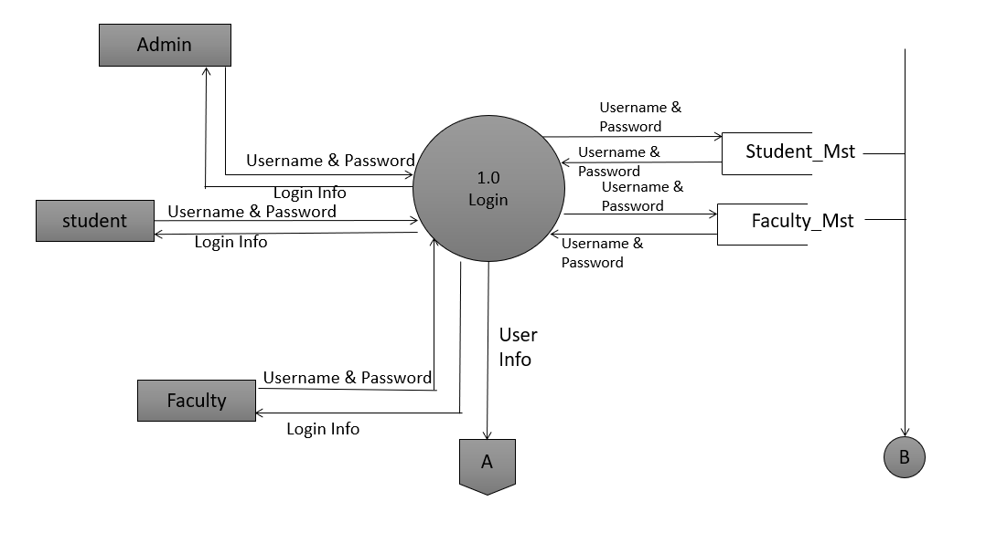

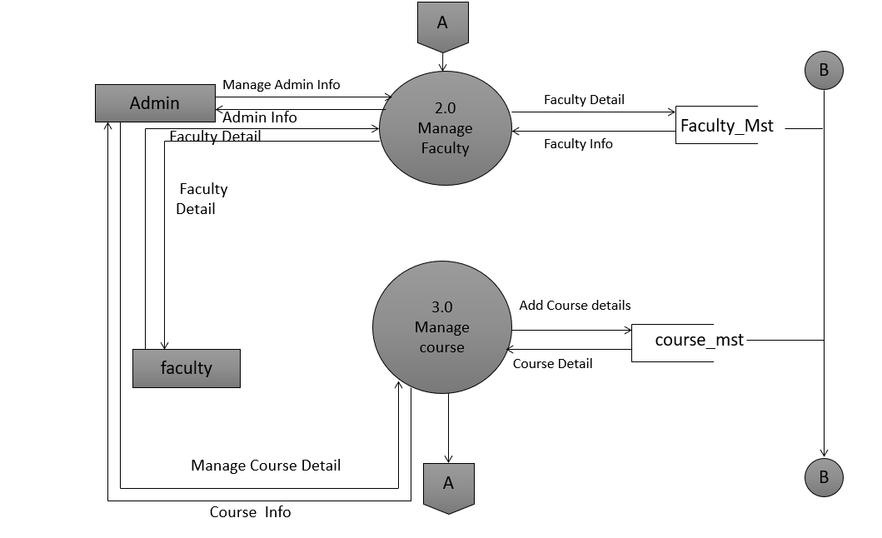

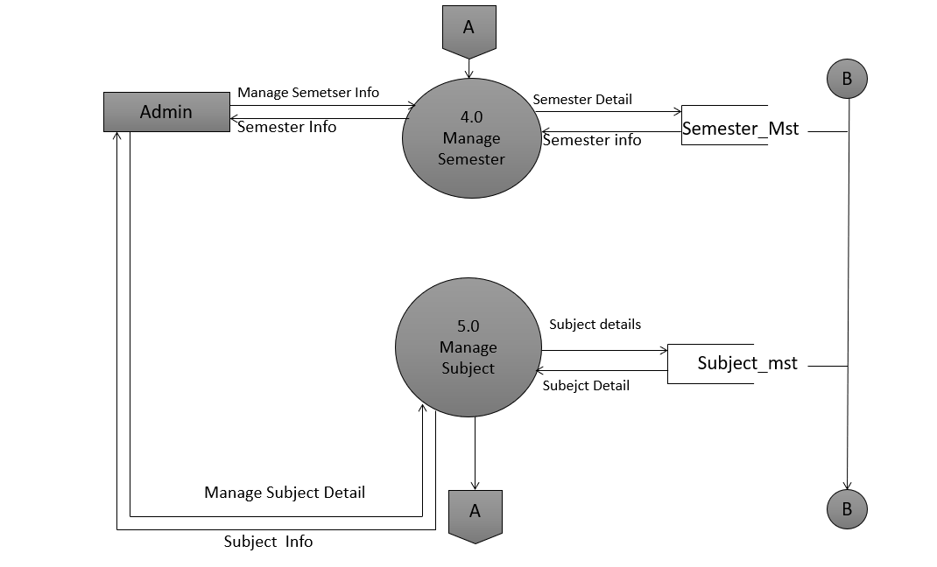

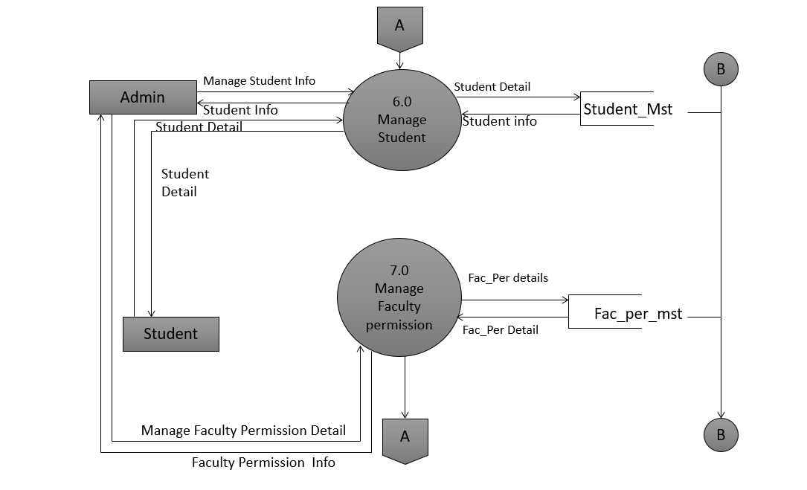

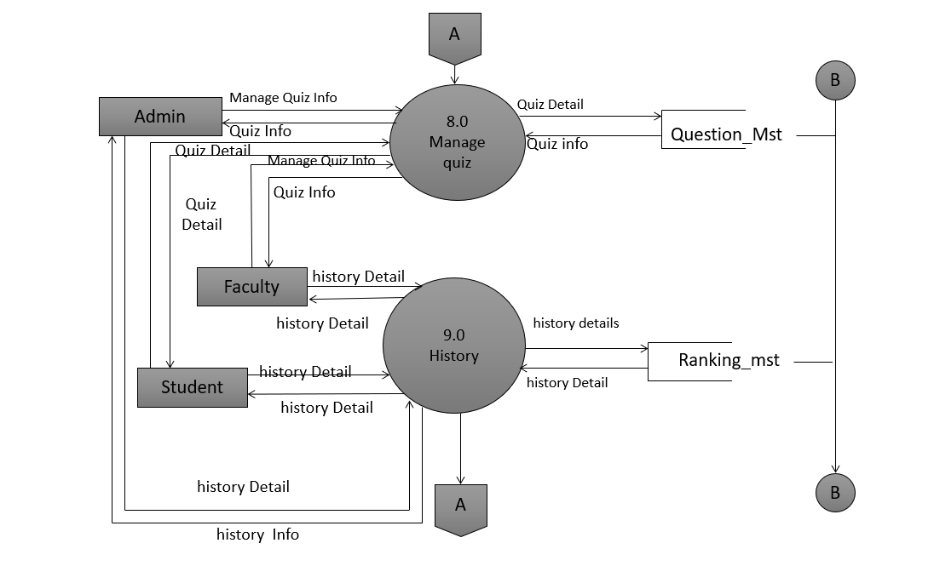

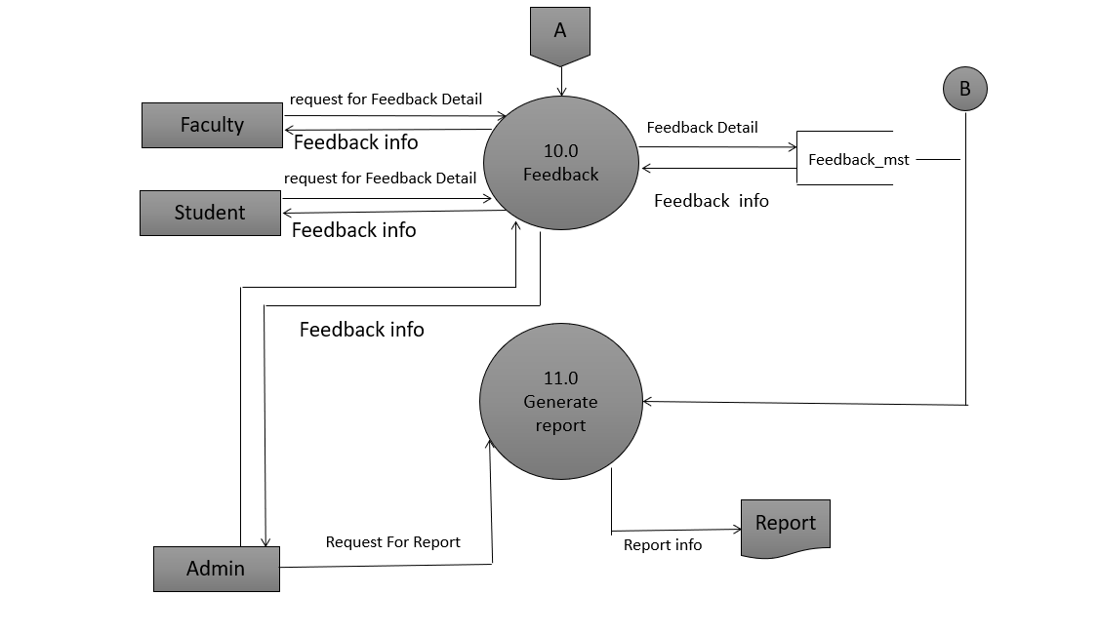

**DATA DICTIONARY**

**DATA TABLE**

* Faculty
* course
* Semester
* Subject
* Student
* Fac_per
* Question
* Choice
* Feedback
* subject_quiz

|  |  |
| --- | --- |
| **Table Name** | Faculty |
| **Primary Key** | f_id |
| **Foreign Key** | **-** |
| **Description** | This table is used to store the Faculty detail. |

|  |  |  |  |  |
| --- | --- | --- | --- | --- |
| Field Name | **Data type (length)** | **Constraints** | **Description** | **Sample data** |
| f_id | Int | Primary Key | It is used to store faculty ID. | 01 |
| f_code | Varchar(50) | not Null | Store the faculty code. | Asd1432 |
| f_mail | Varchar(50) | Not Null | Store the Faculty email. | R1@gmail.com |
| f_Mobile | varchar(10) | Not null | Store the faculty contact number. | 9021365485 |
| f_name | Varchar(500) | Not null | Store the faculty name. | Raj |
| f_Password | Varchar (15) | Not null | Store the faculty password. | **** |
| F_type | Varchar(10) | Not null | Store the type of faculty.  (admin/faculty) | admin |

|  |  |
| --- | --- |
| **Table Name** | Course |
| **Primary Key** | course_id |
| **Foreign Key** | **-** |
| **Description** | To Store Student student course.(UG/PG) |

|  |  |  |  |  |
| --- | --- | --- | --- | --- |
| **Field Name** | **Data type (length)** | **Constraints** | **Description** | **Sample data** |
| course_id | Int | Primary Key, Auto Increment, Not Null | Store the course Id. | 01 |
| course_code | Varchar (20) | Not Null | Store the course code. | U1 |
| course_name | Varchar (50) | Not Null | Store the course name. | Bsc (ca & it) |
| course_type | Varchar (2) | Not Null | Store the course type.  ( UG / PG ) | UG |

|  |  |
| --- | --- |
| **Table Name** | Semester |
| **Primary Key** | Sem_id |
| **Foreign Key** | course_id(Ref:-course(course_id). |
| **Description** | This table is used to store student semester details. |

|  |  |  |  |  |
| --- | --- | --- | --- | --- |
| **Field Name** | **Data type (length)** | **Constraints** | **Description** | **Sample data** |
| Sem_id | Int | Primary Key, | It is used to Store the sem id. | 01 |
| course_id | int | Foreign key | Store the course id. | 3 |
| Sem_code | Varchar (20) | Not Null | Store the sem code. | U15 |
| Sem_type | varchar (4) | Not null | Store the semester type.  (odd / even) | odd |

|  |  |
| --- | --- |
| **Table Name** | Subject |
| **Primary Key** | Sub_id |
| **Foreign Key** | sem_id(Ref:-semester(sem_id). |
| **Description** | To store subject of the quiz |

|  |  |  |  |  |
| --- | --- | --- | --- | --- |
| **Field Name** | **Data type (length)** | **Constraints** | **Description** | **Sample data** |
| Sub_id | Int | Primary Key | It is used to Store the subject id. | 01 |
| Sem_id | Int | Foreign key | Store the semester id. | 1 |
| Sub_code | Varchar (20) | Not Null | Store the subject code. | U15ABWD |
| Sub_name | char (100) | Not null | Store the subject name. | php |

|  |  |
| --- | --- |
| **Table Name** | Student |
| **Primary Key** | Stud_id |
| **Foreign Key** | Sem_id(Ref:-semester(sem_id). |
| **Description** | This table is used to store student details. |

|  |  |  |  |  |  |
| --- | --- | --- | --- | --- | --- |
| **Sr.No.** | **Field Name** | **Data Type** | **Constraint** | **Description** | **Sample** |
| 1 | Stud_id | INT | Primary key | Store the student id. | 1 |
| 2 | Sem_id | Int | Foreign key | Store the semester id. | 3 |
| 3 | Stud_code | Varchar(13) | Not null | Store the student code. | 17082221024 |
| 4 | Stud_name | Varchar(50) | Not null | Store the student name. | Rahul |
| 5 | Stud_password | Varchar(20) | Not null | Store the student password. | **** |
| 6 | Stud_mail | Varchar(50) | Not null | Store student mail id. | [m11@gmail.com](mailto:m11@gmail.com) |
| 7 | Stud_mobile | Varchar(10) | Not null | Store the student mobile number. | 8511059330 |

|  |  |
| --- | --- |
| **Table Name** | Fac_per |
| **Primary Key** | Facperid |
| **Foreign Key** | fid(Ref:-Faculty(fid),  subid(Ref:-Subject(subid). |
| **Description** | This table is used To store faculty permission. |

|  |  |  |  |  |  |
| --- | --- | --- | --- | --- | --- |
| **Sr.No.** | **Field Name** | **Data Type** | **Constraint** | **Description** | **sample** |
| 1 | Facperid | Int | Primary key | Store the faculty permission id. | 1 |
| 2 | Fid | Int | Foreign key | Store the faculty id. | 1 |
| 3 | Subid | Int | Foreign key | Store the subject id. | 1 |

|  |  |
| --- | --- |
| **Table Name** | Question |
| **Primary Key** | Qno |
| **Foreign Key** | subid(Ref:-Subject(subid). |
| **Description** | This table is used To store the quiz question details. |

|  |  |  |  |  |  |
| --- | --- | --- | --- | --- | --- |
| **Sr.No.** | **Field Name** | **Data Type** | **Constraint** | **Description** | **sample** |
| 1 | Subid | Int | Foreign key | Store the subject id. | 1 |
| 2 | Qno | Int | Primary key | Store the question no. | 1 |
| 3 | Quizno | Varchar(10) | Not null | Store the quiz number. | php1 |
| 4 | Question | Varchar(1000) | Not null | Store the question for quiz. | Full form of php. |
| 5 | Option1 | Varchar(200) | Not null | Store the option. | Hypertext preprocessor |
| 6 | Option2 | Varchar(200) | Not null | Store the option. | Personal home page |
| 7 | Option3 | Varchar(200) | Not null | Store the option. | None of this |
| 8 | Option4 | Varchar(200) | Not null | Store the option. | A & b both |
| 9 | Trueoption | Varchar(200) | Not null | Store the right option. | A & b both |

|  |  |
| --- | --- |
| **Table Name** | Choice |
| **Primary Key** | choise_id |
| **Foreign Key** | q_id(Ref:-Question(q_id),  Stud_id(Ref:-Student(Stud_id). |
| **Description** | This table is used To store the result of the quiz. |

|  |  |  |  |  |  |
| --- | --- | --- | --- | --- | --- |
| **Sr.No.** | **Field Name** | **Data Type** | **Constraint** | **Description** | **sample** |
| 1 | choice_id | Int | Primary key | Store the choice id. | 1 |
| 2 | q_id | Int | Foreign key | Store the Qno. | 1 |
| 3 | stud_id | Int | Foreign key | Store the student id. | 1 |
| 4 | Choice_option | Varchar(1) | Not null | Store the choice option of the quiz. | A & b both |
| 5 | Result | Varchar(5) | Not null | Store the result of the choice (Y / N) | Y |

|  |  |
| --- | --- |
| **Table Name** | Feedback |
| **Primary Key** | Fb_id |
| **Foreign Key** | Stud_id(Ref:-Student(Stud_id) |
| **Description** | This table is used to store the feedback |

|  |  |  |  |  |  |
| --- | --- | --- | --- | --- | --- |
| **Sr.No.** | **Field Name** | **Data Type** | **Constraint** | **Description** | **sample** |
| 1 | fb_id | Int | Primary key | Store the feedback id. | 1 |
| 2 | Stud_id | Int | Foreign key | Store the student id. | 1 |
| 3 | title | Varchar(200) | Not null | Store the title of feedback. | Question |
| 3 | Comment | Varchar(5000) | Not null | Store the feedback. | Best system for the online quiz system. |

|  |  |
| --- | --- |
| **Table Name** | subject_quiz |
| **Primary Key** | sub_quiz_id |
| **Foreign Key** | Sub_id(Ref:-Subject(Sub_id) |
| **Description** | This table is used to store the quiz. |

|  |  |  |  |  |  |
| --- | --- | --- | --- | --- | --- |
| **Sr.No.** | **Field Name** | **Data Type** | **Constraint** | **Description** | **sample** |
| 1 | Sub_quiz_id | Int | Primary key | Store the subject quiz id. | 1 |
| 2 | Stud_id | Int | Foreign key | Store the student id. | 1 |
| 3 | Quiz_no | Varchar(20) | Not null | Store the quiz no. | Php1 |

***INPUT DESIGN***

**ADMIN SIDE**

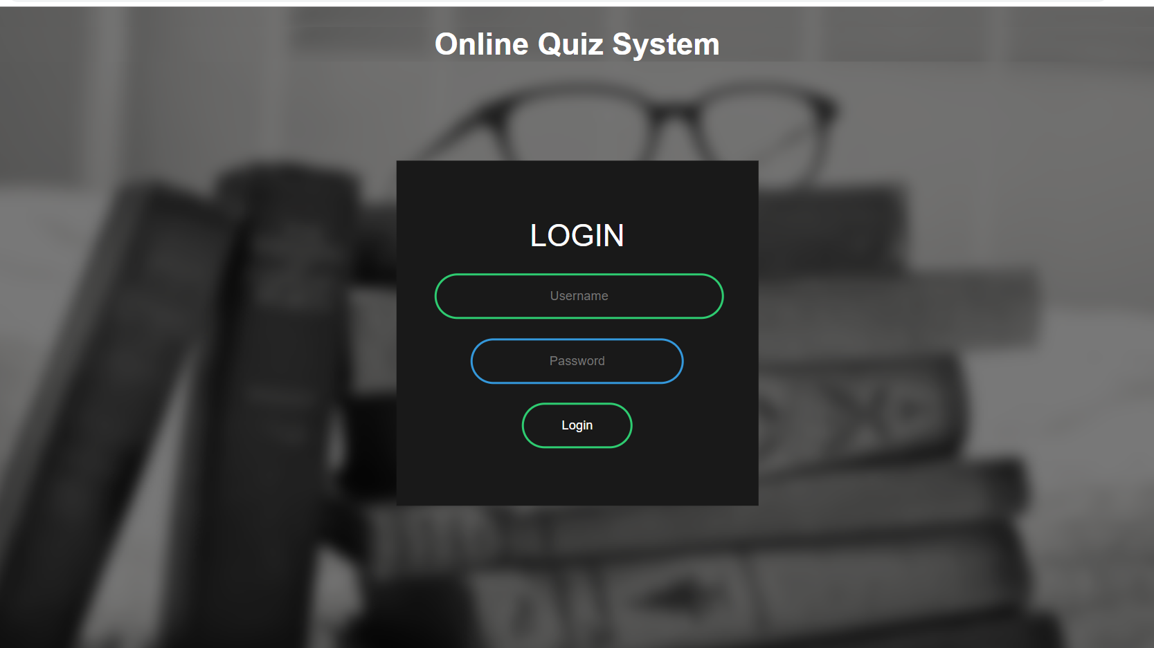

Description:-This is home page of admin,faculty and students.

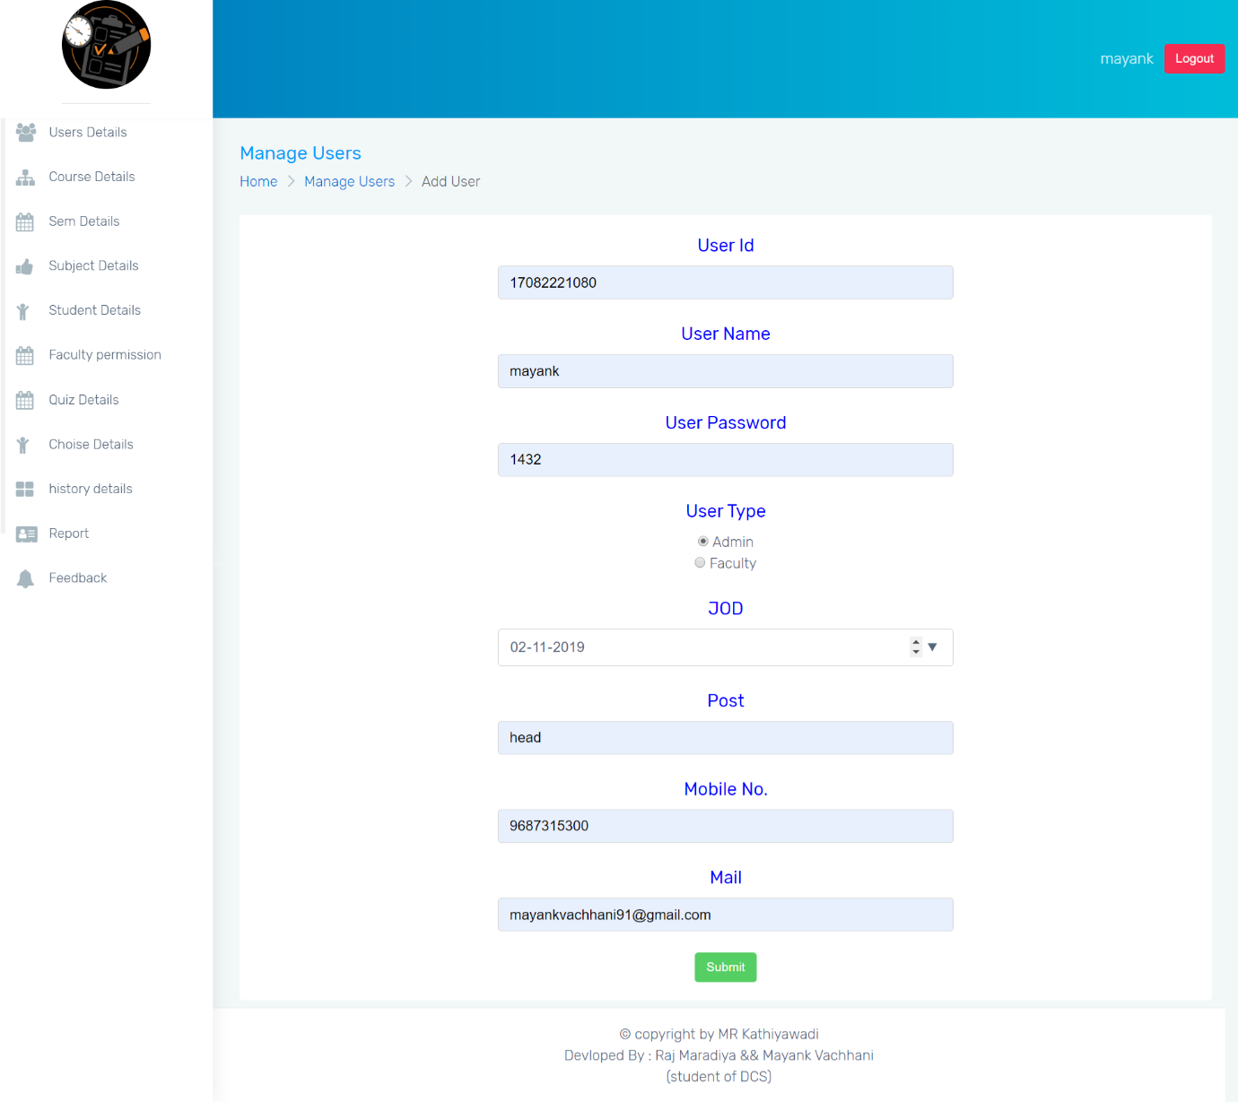

Description:-This page is add admin and faculty.

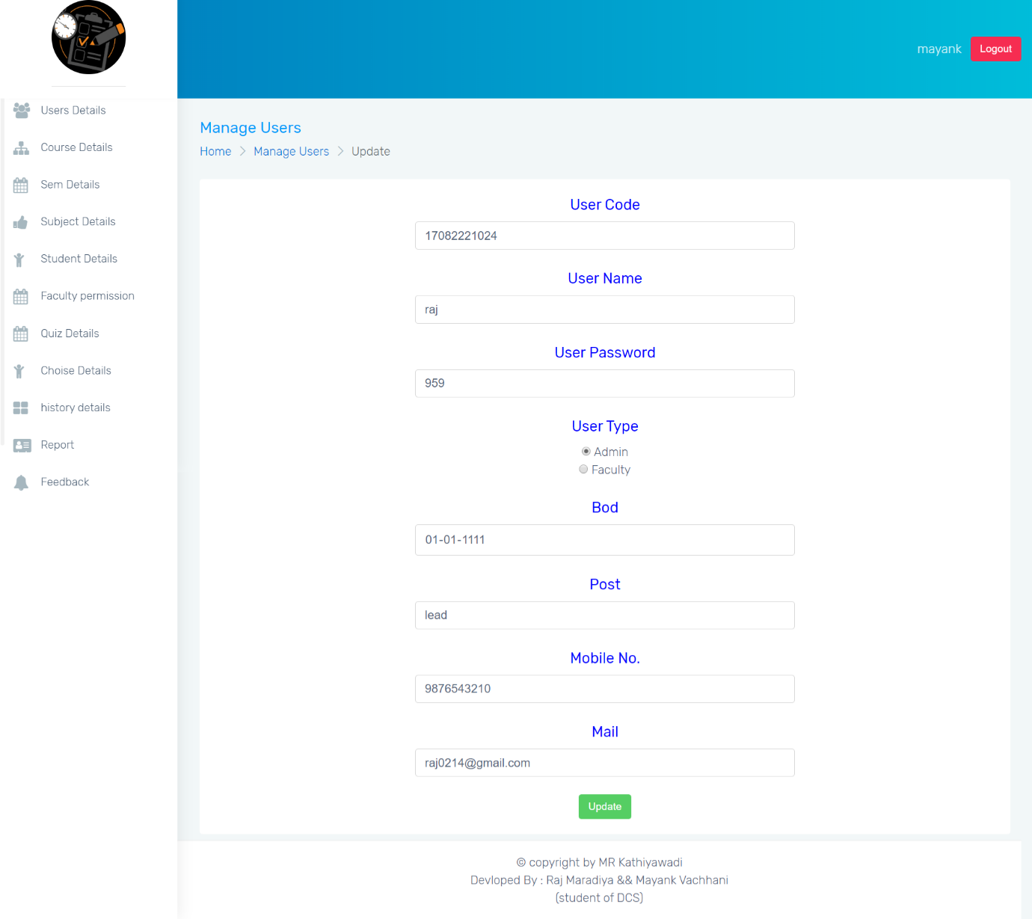

Description:-This page is update admin and faculty details.

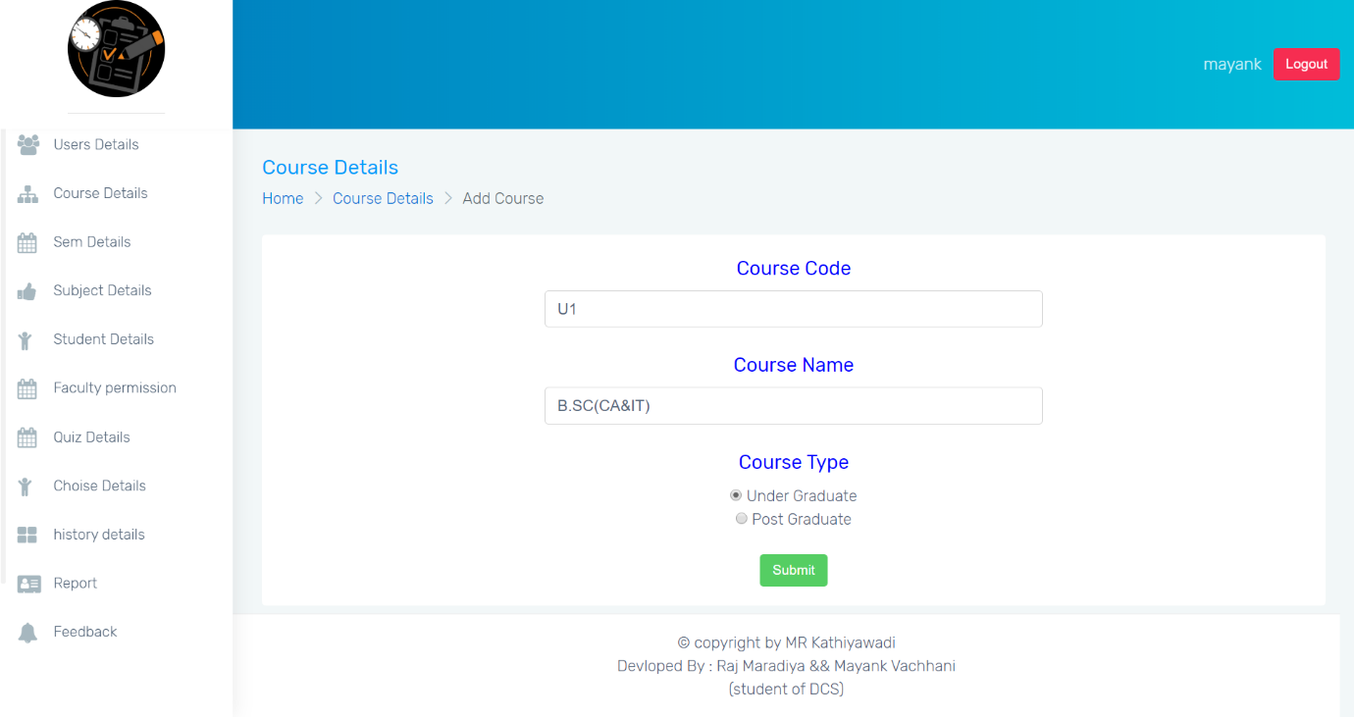

Description:-This page is add cource details.

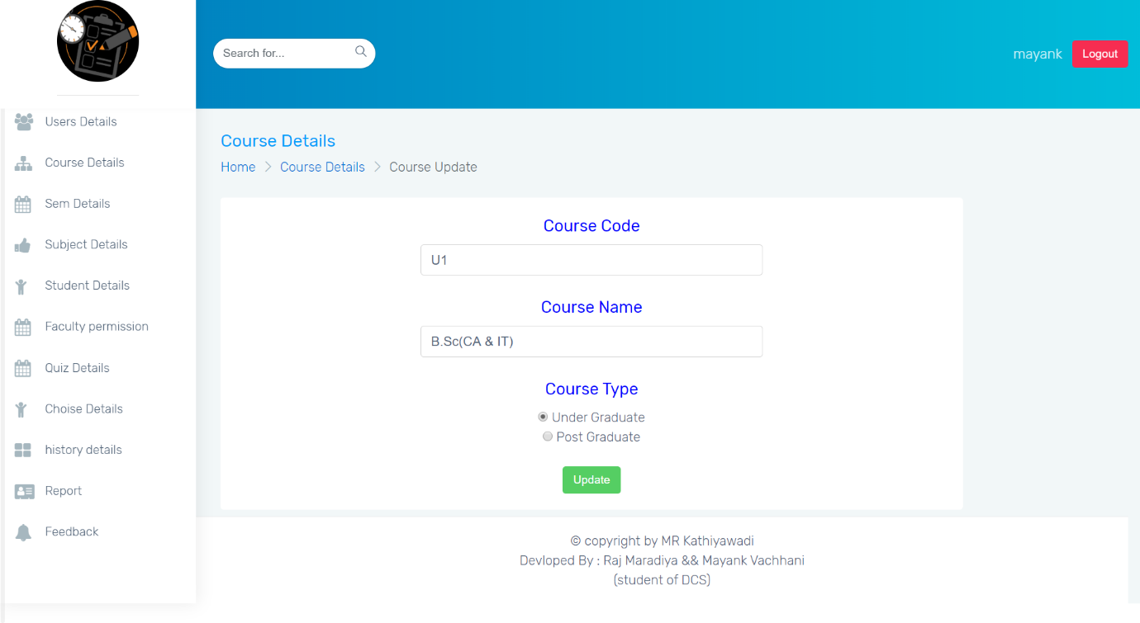

Description:-This page is update cource.

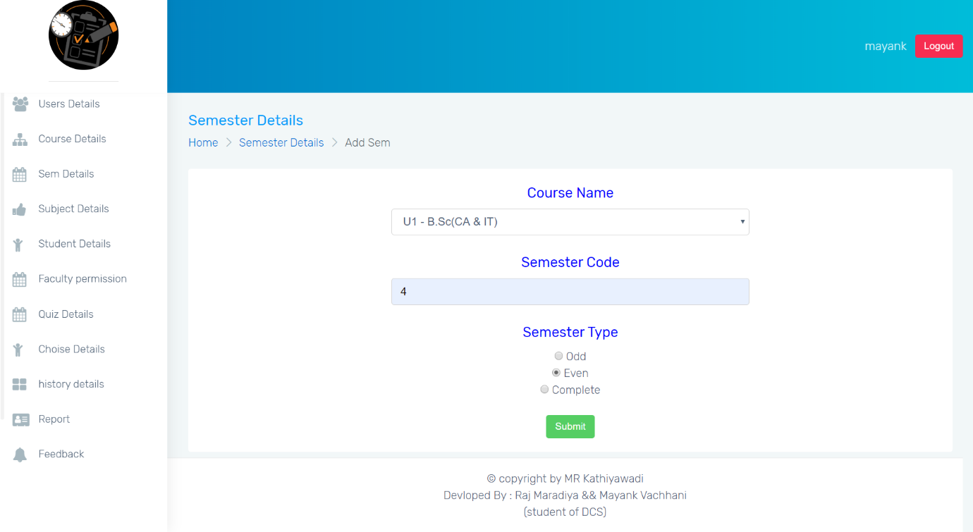

Description:-This page is add semester details.

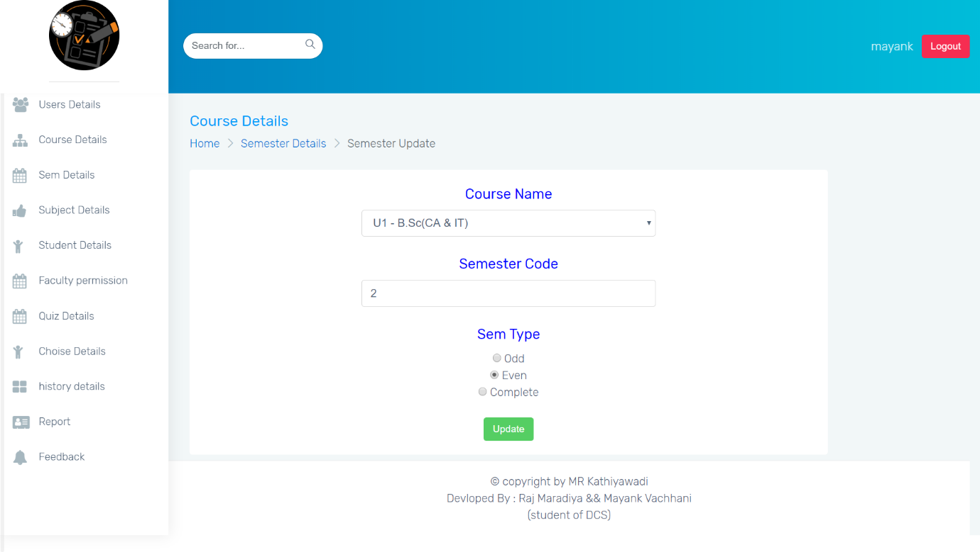

Description:-This page is update semester.

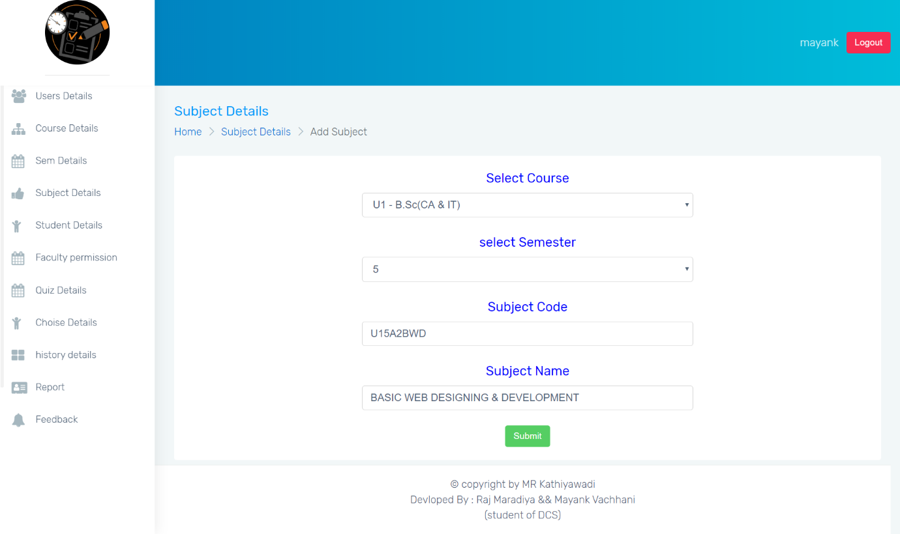

Description:-This page is add subject.

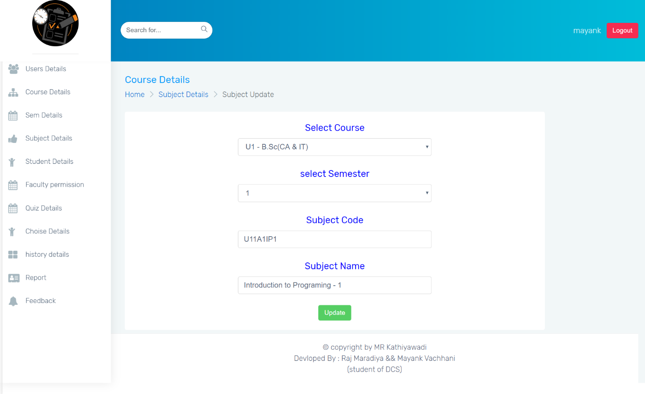

Description:-This page is update cource.

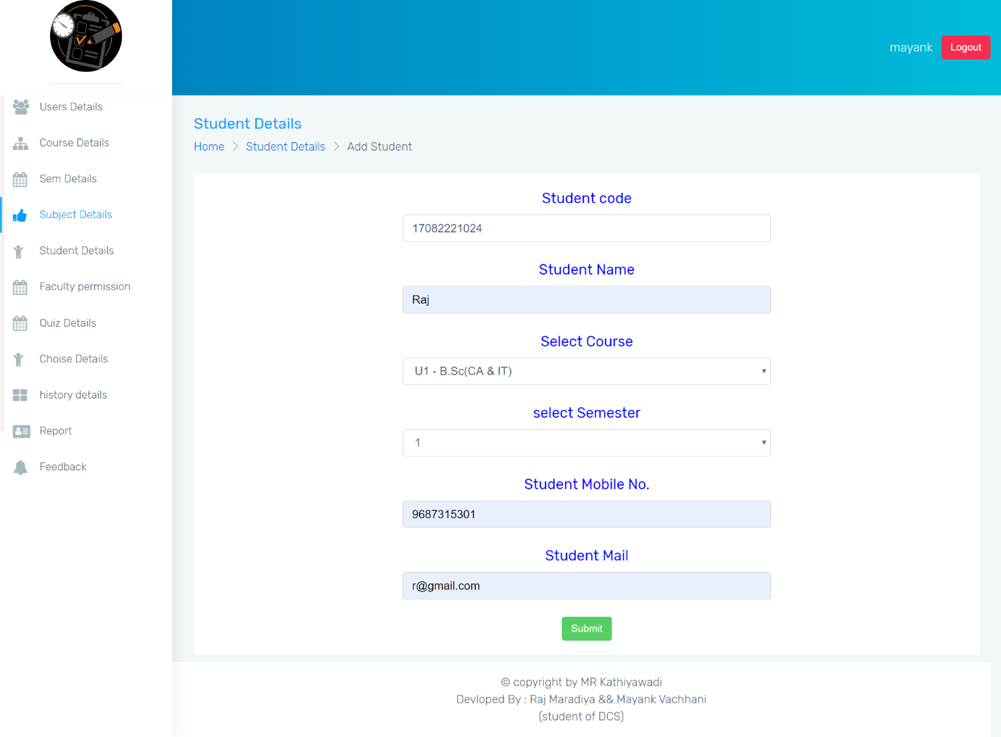

Description:-This page is add student.

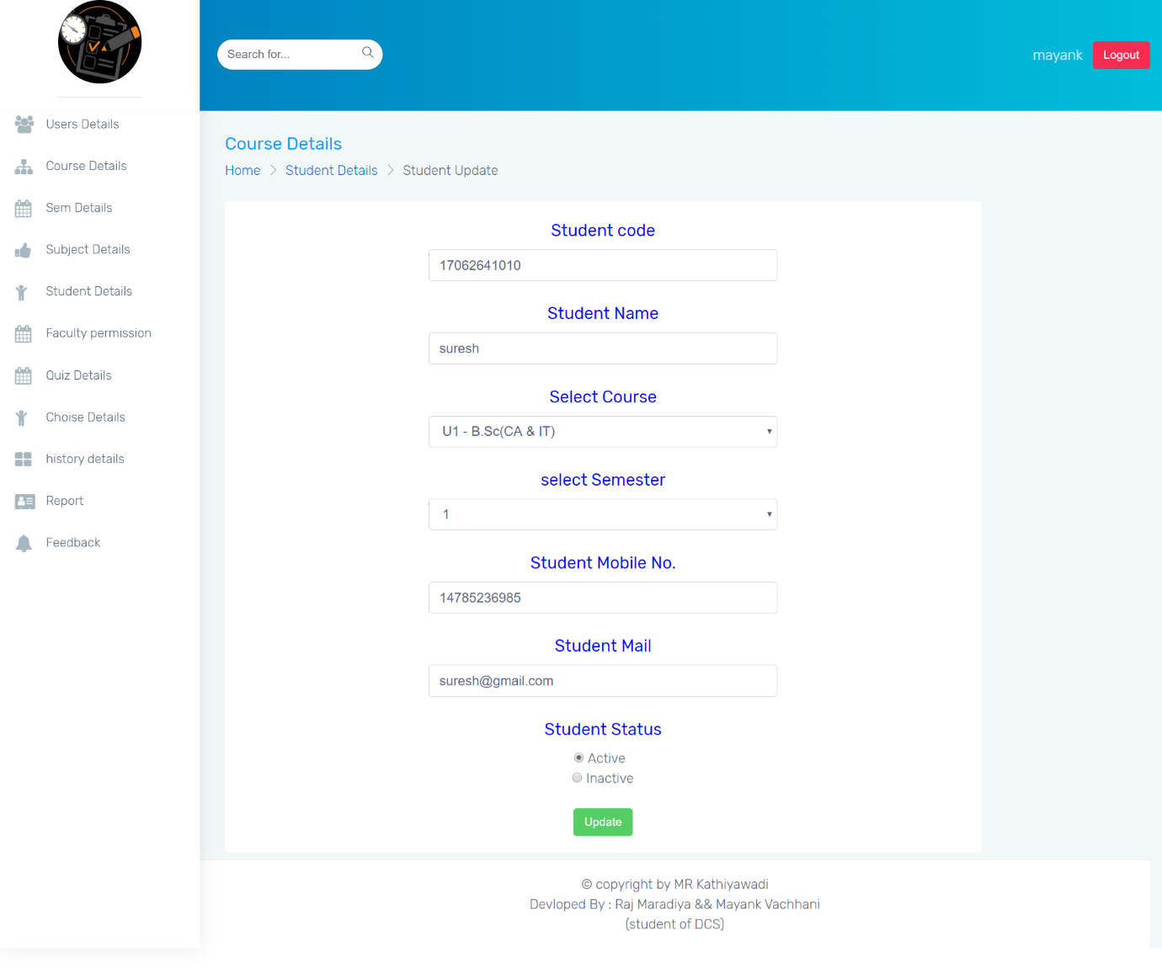

Description:-This page is update student.

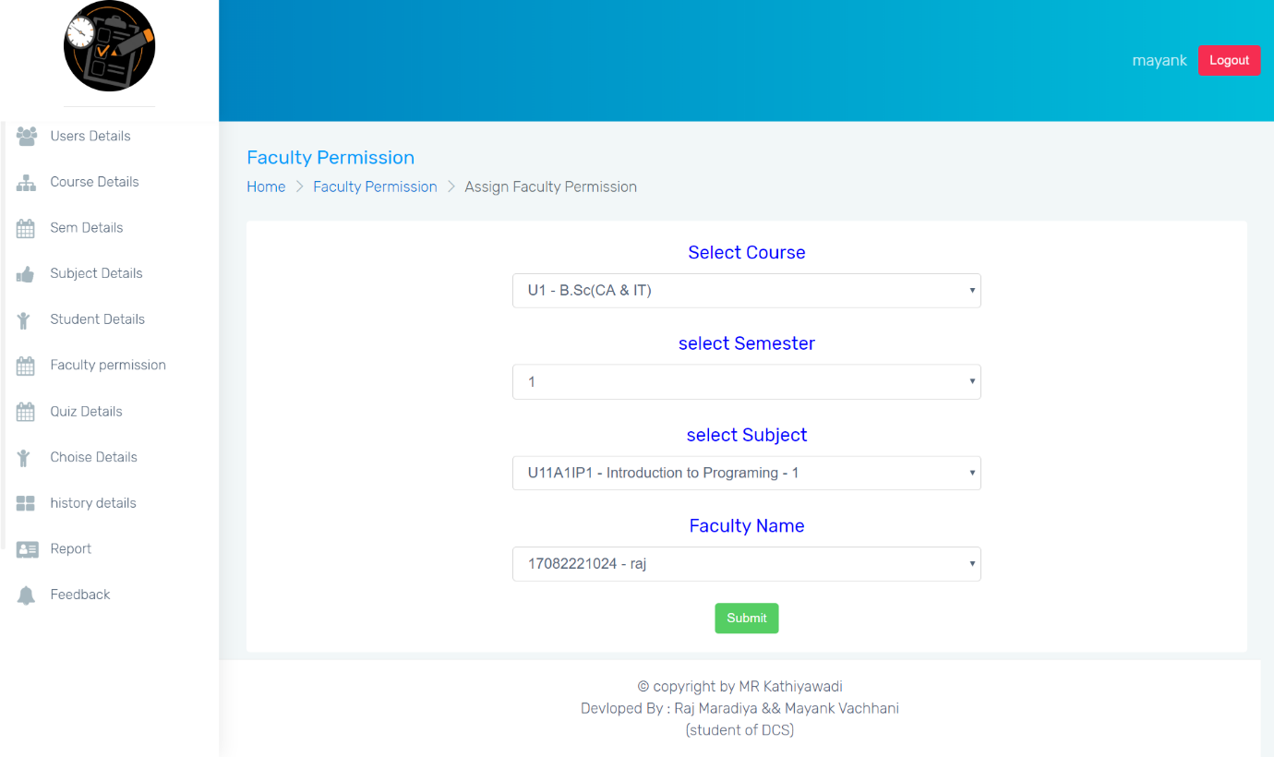

Description:-This page is add assign faculty permission.

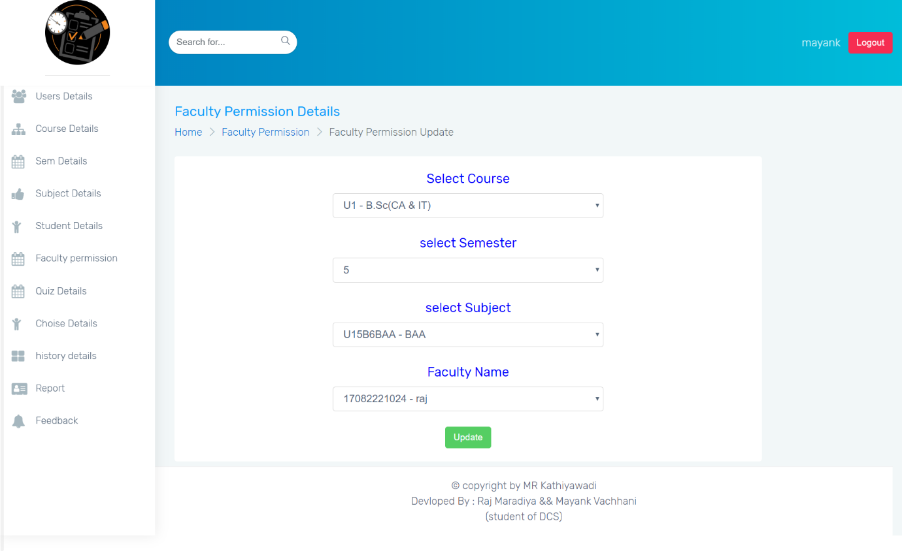

Description:-This page is update faculty permission.

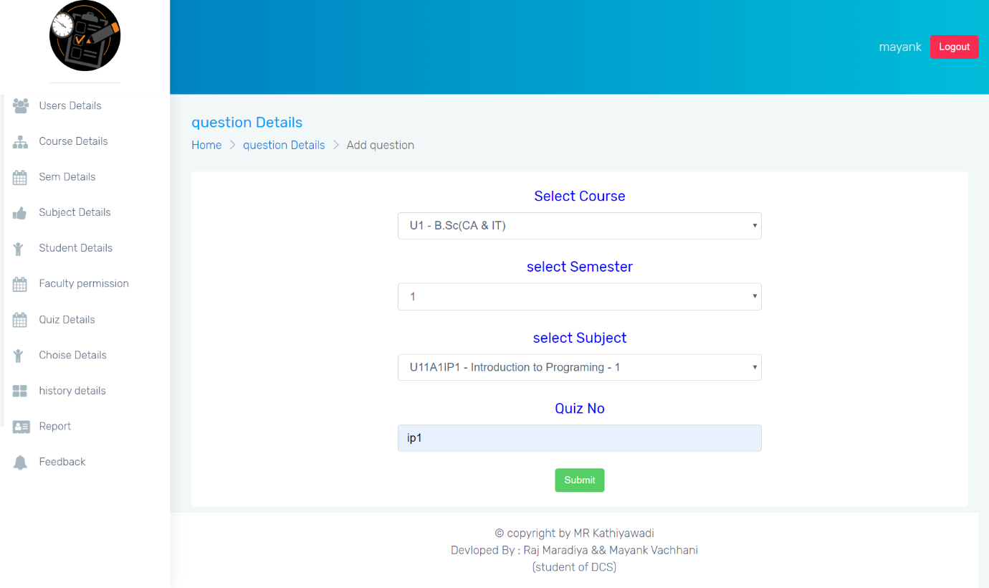

Description:-This page is add quiz subject.

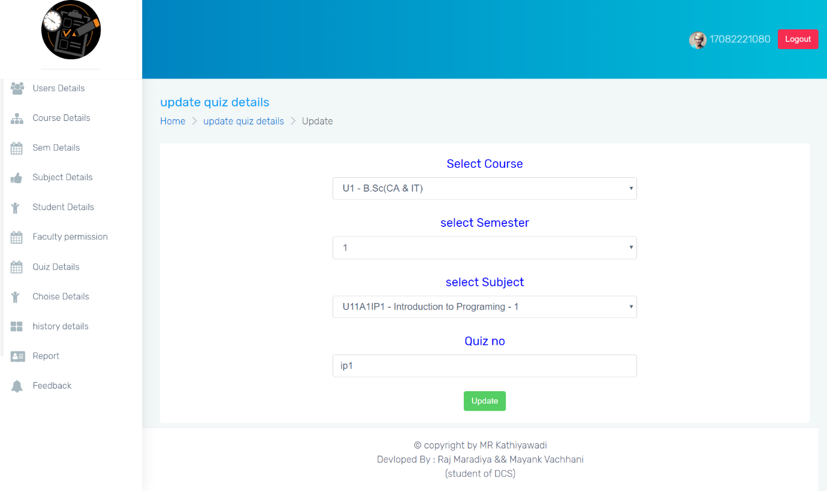

Description:-This page is update quiz subject.

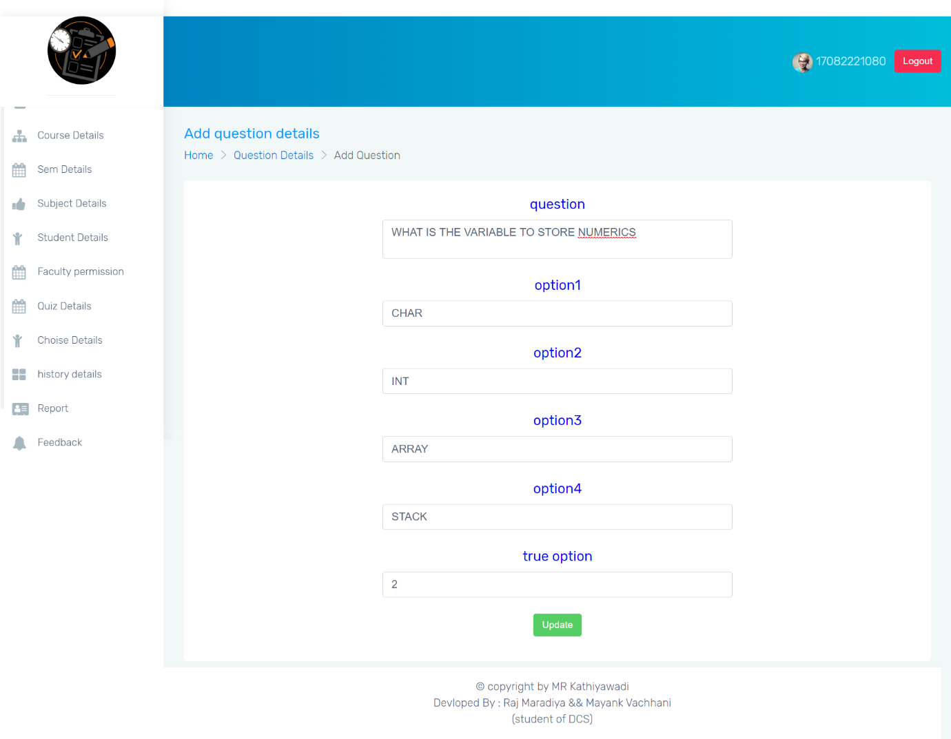

Description:-This page is add question.

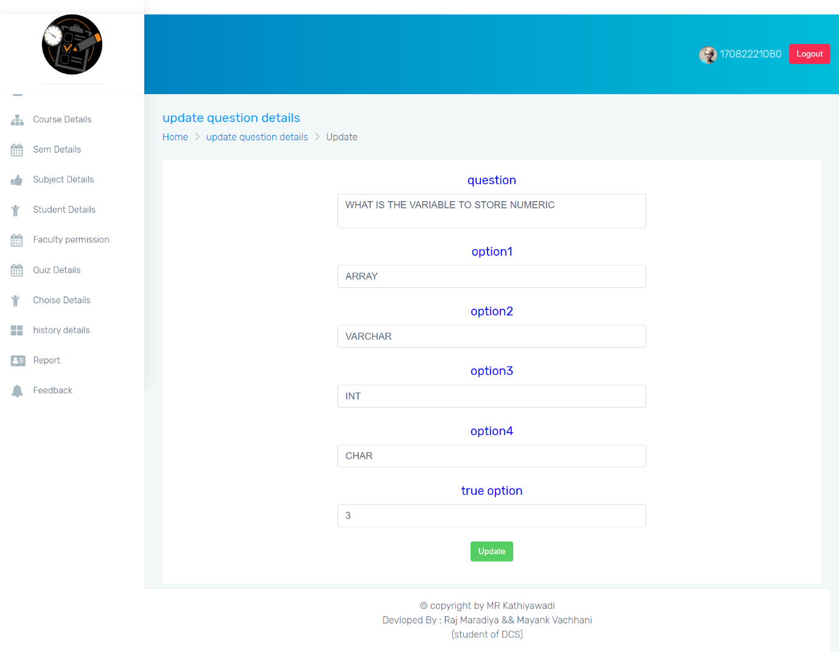

Description:-This page is update question.

**USER SIDE**

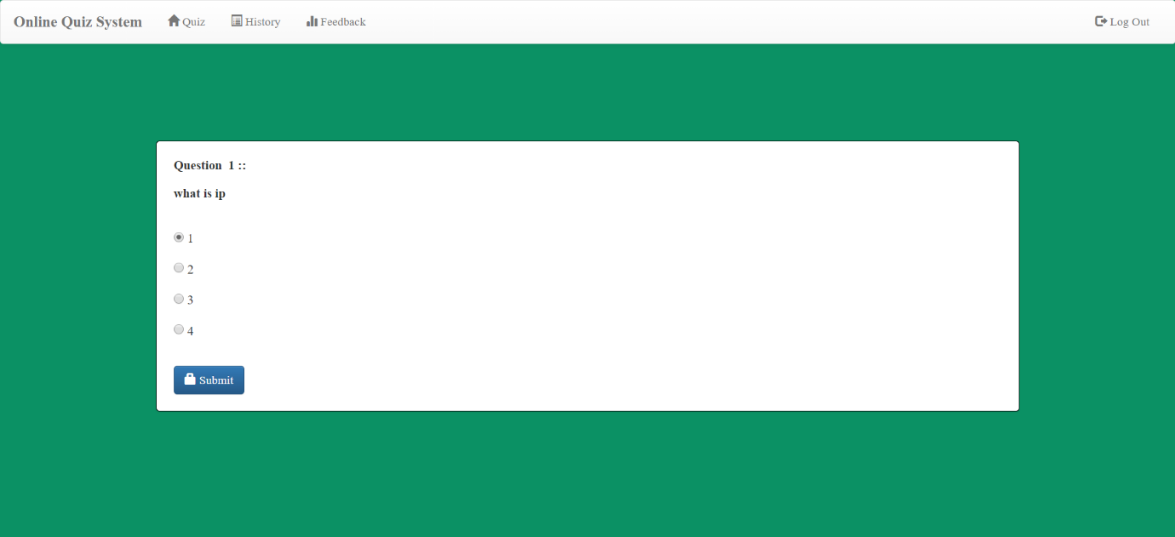

Description:-This page is attempt quiz.

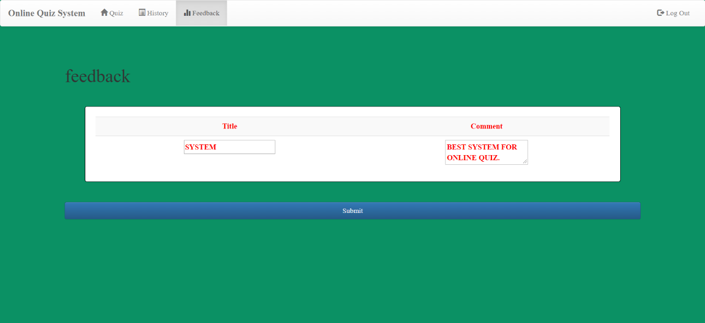

Description:-This page is give feedback.

**OUTPUT**

**ADMIN SIDE**

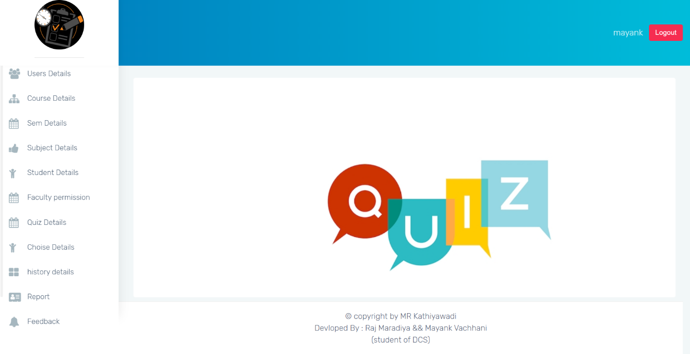

Description:-This page is home page of admin.

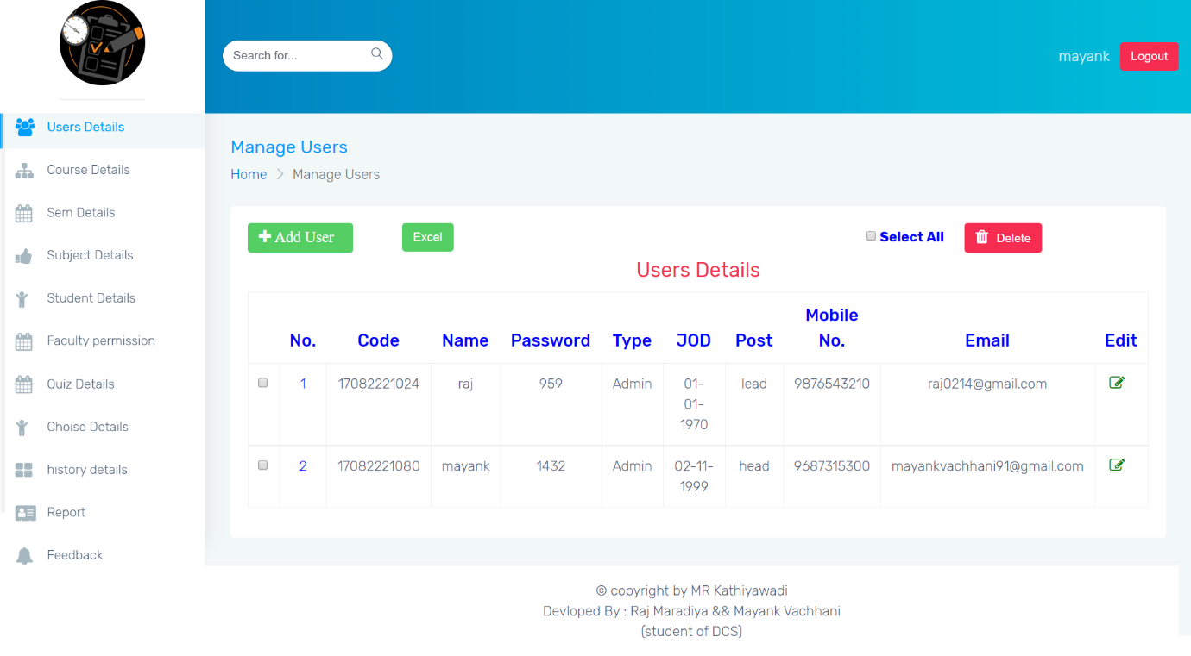Description:-This page is display user details.

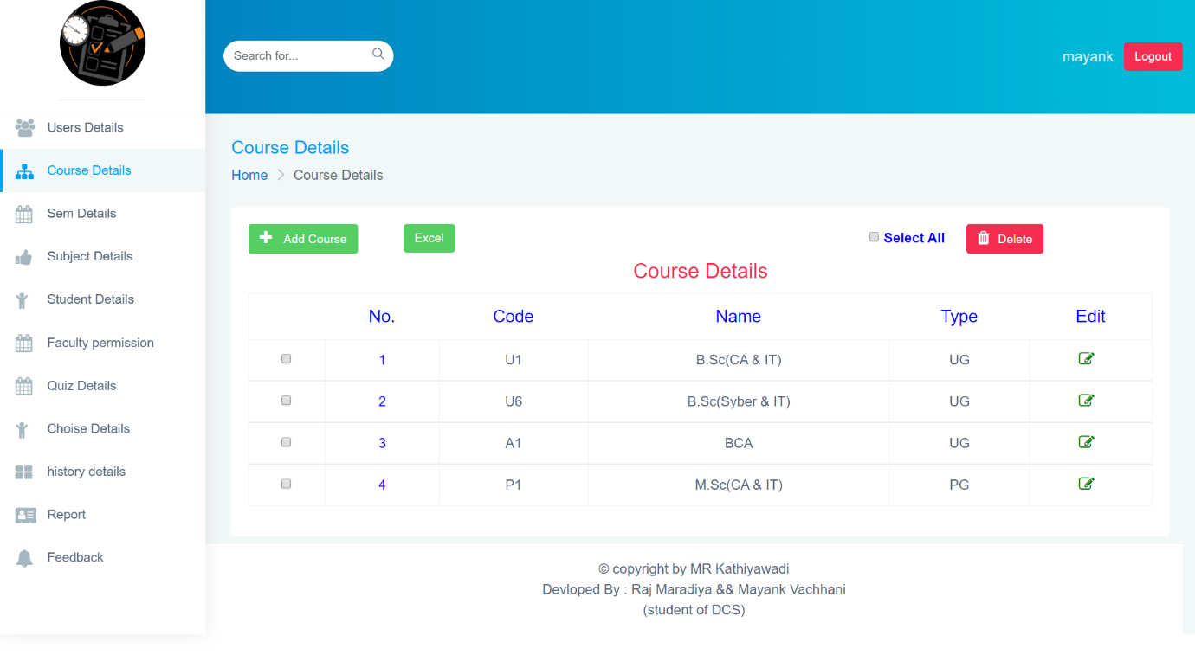

Description:-This page is display cource details.

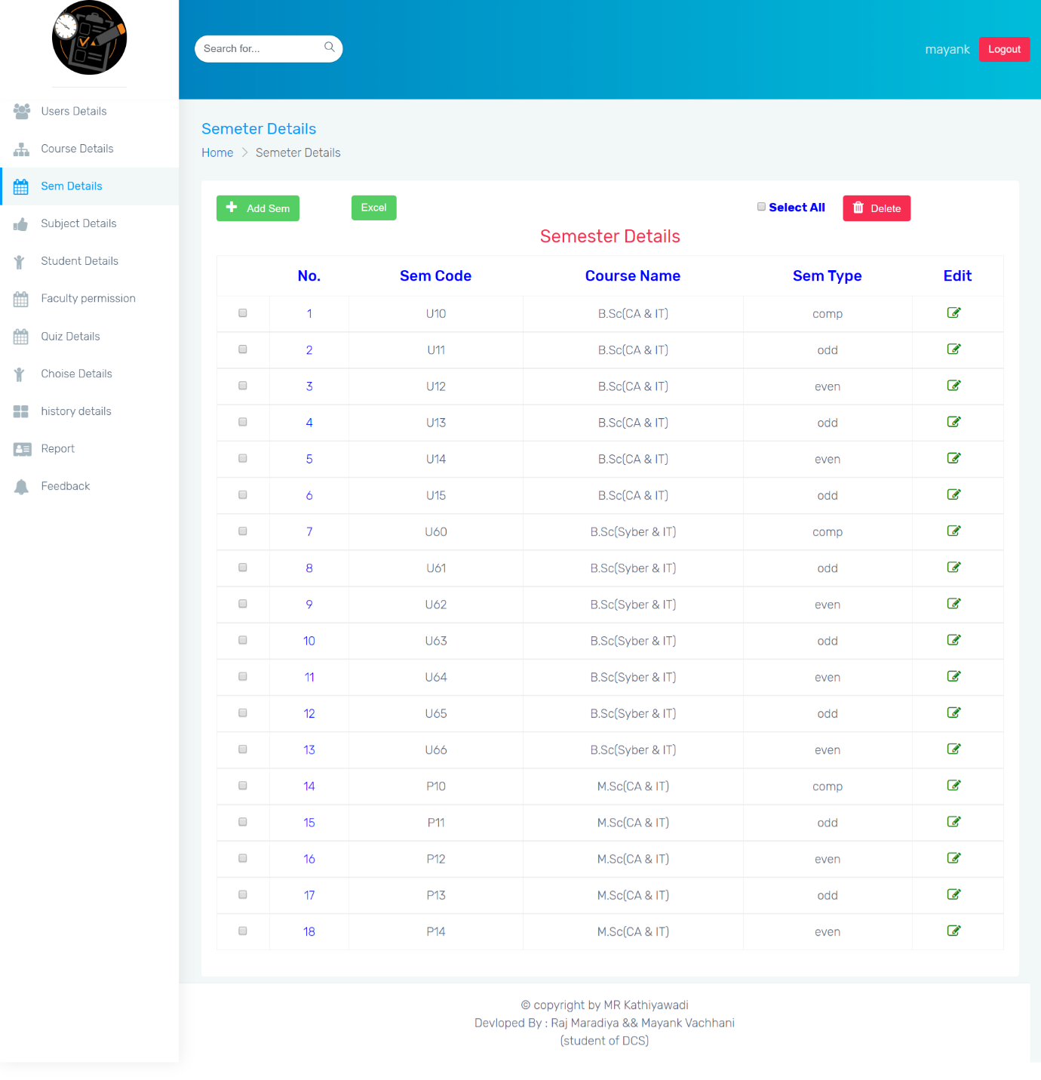

Description:-This page is display semester details.

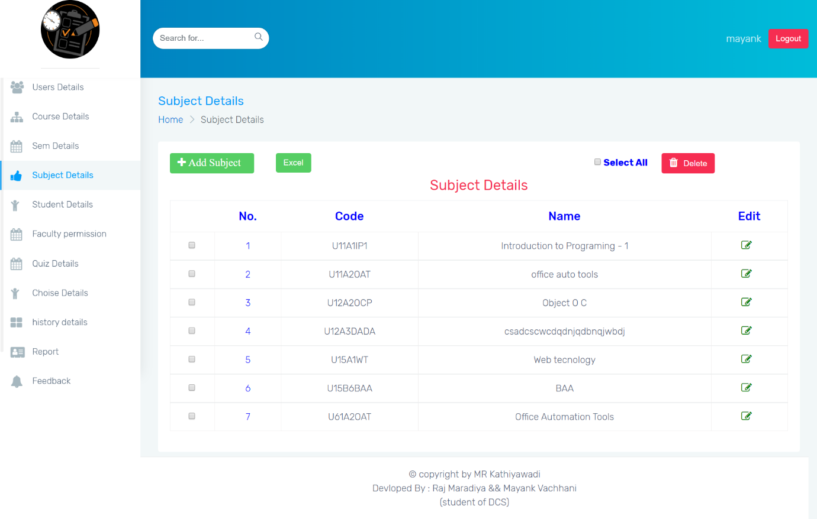

Description:-This page is display subject details.

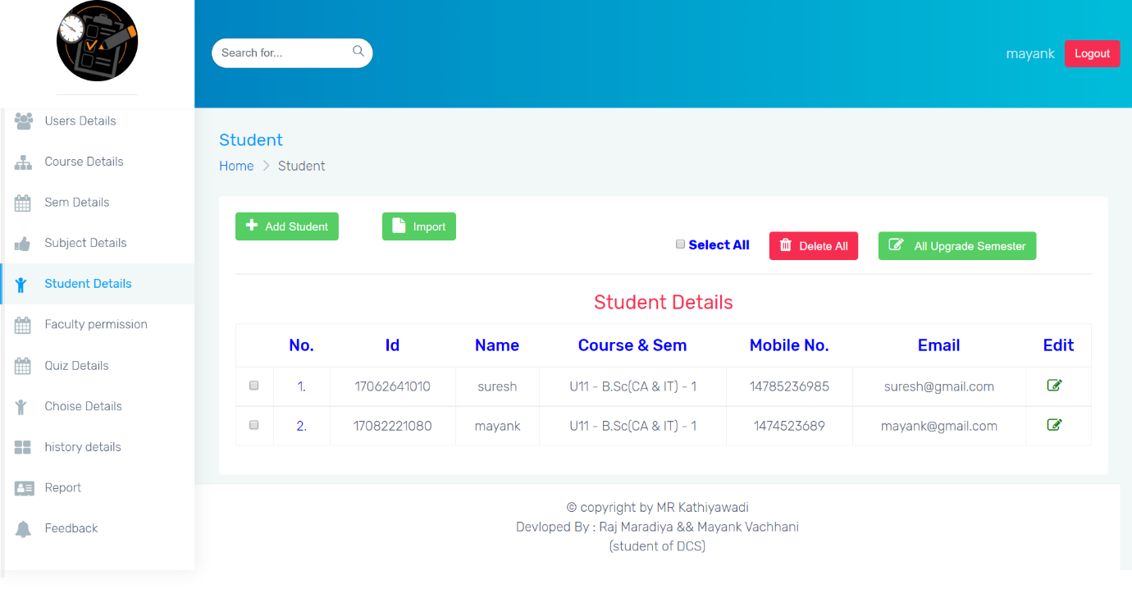

Description:-This page is display student details.

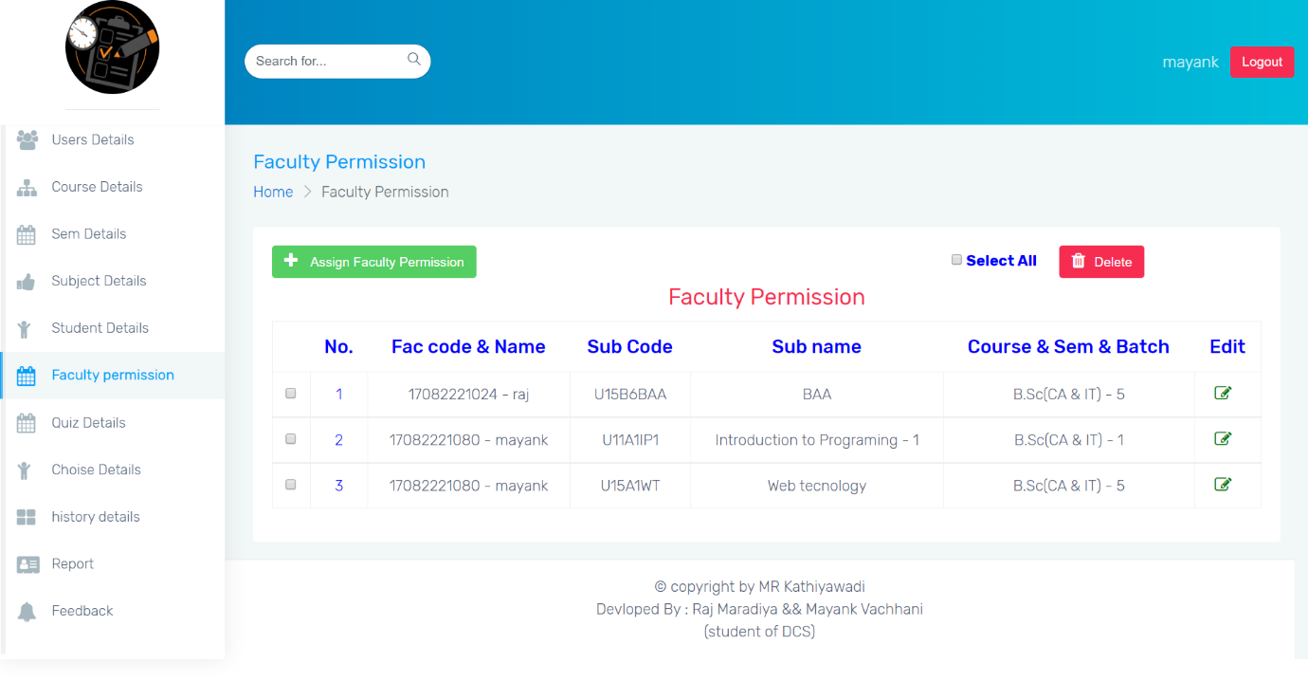

Description:-This page is display faculty permission details.

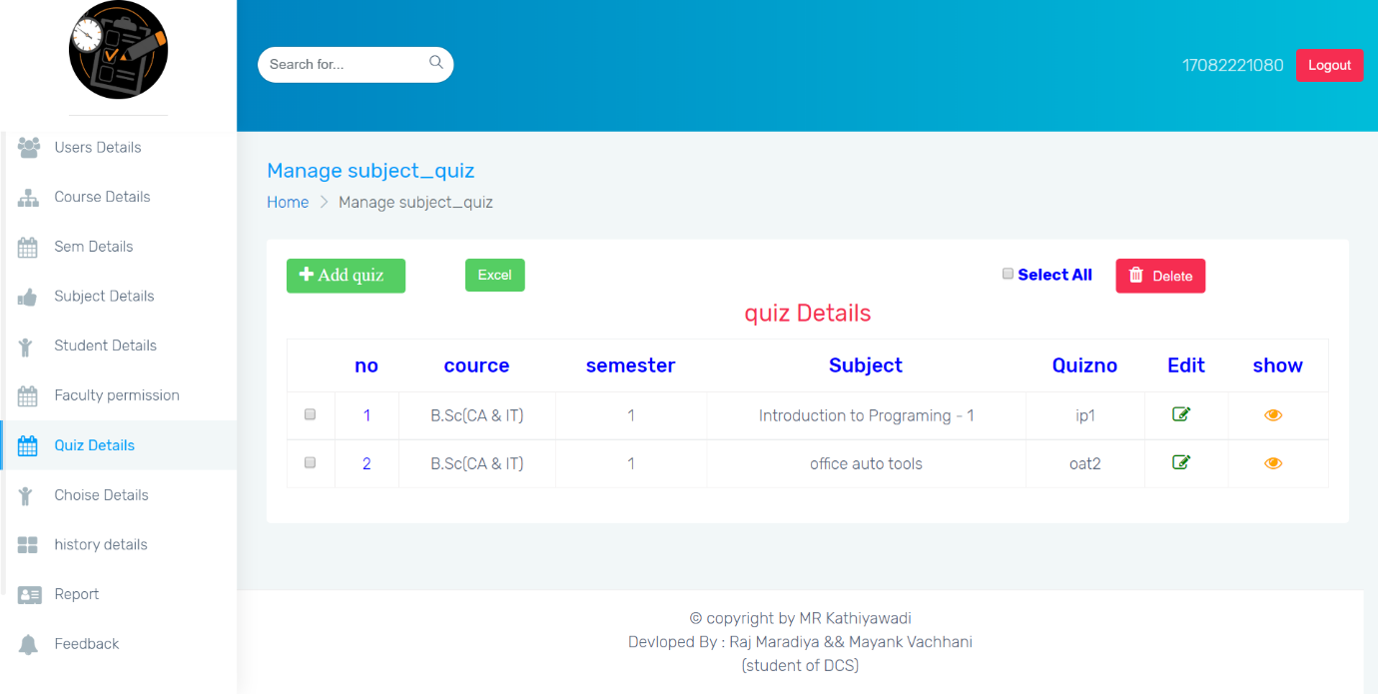

Description:-This page is display subject quiz details.

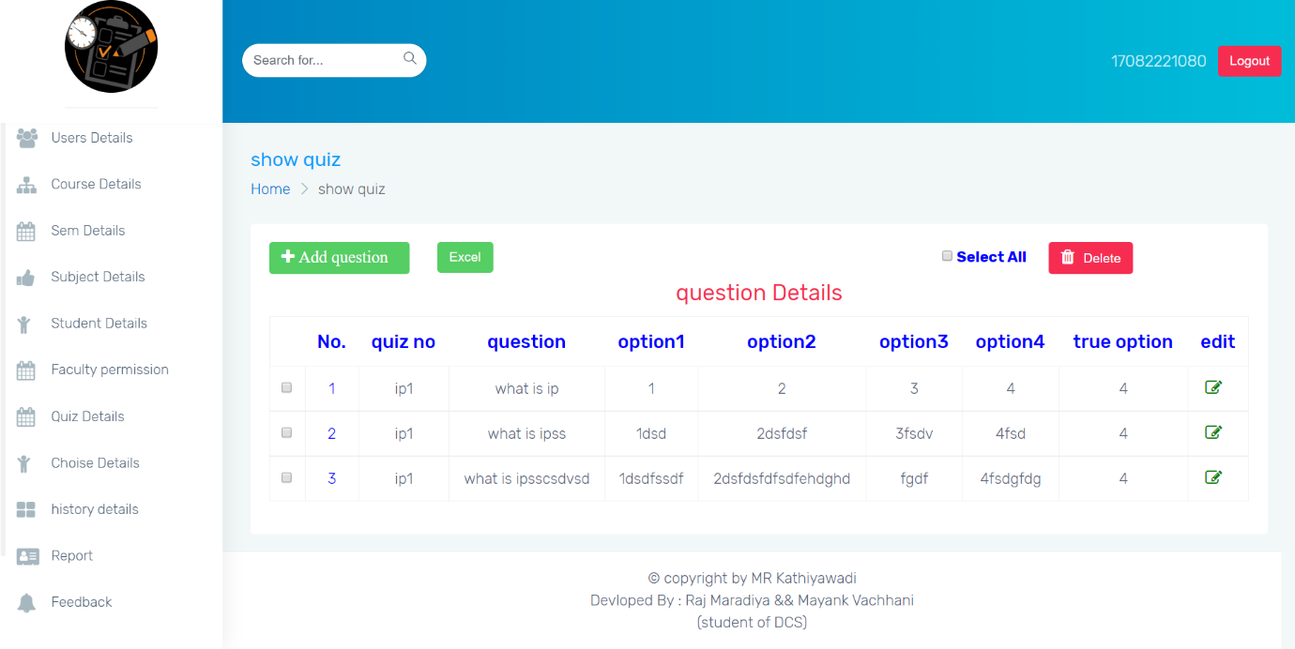

Description:-This page is display question details.

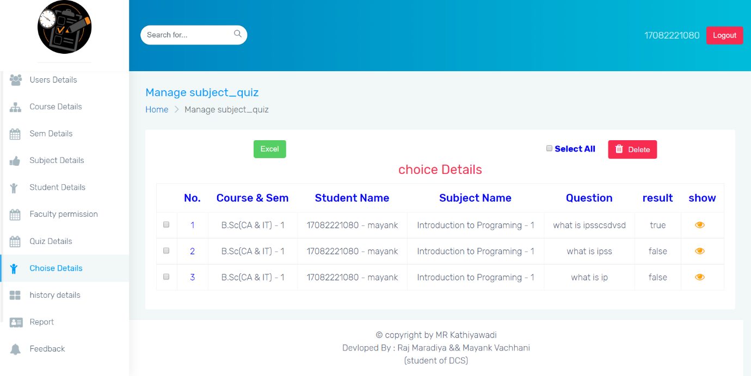

Description:-This page is display user choice details.

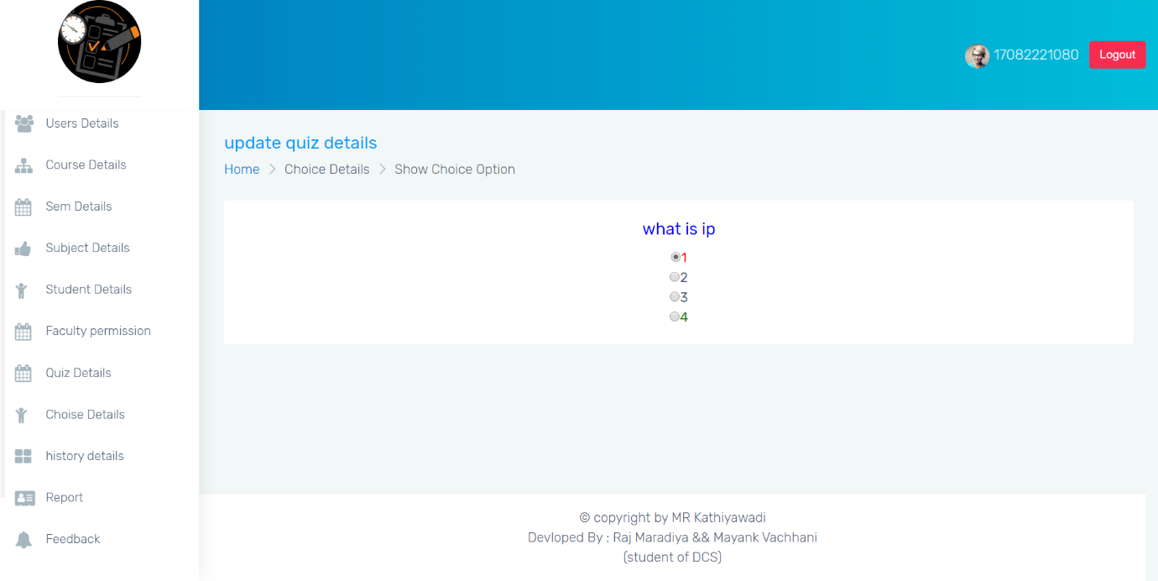

Description:-This page is display choice option details.

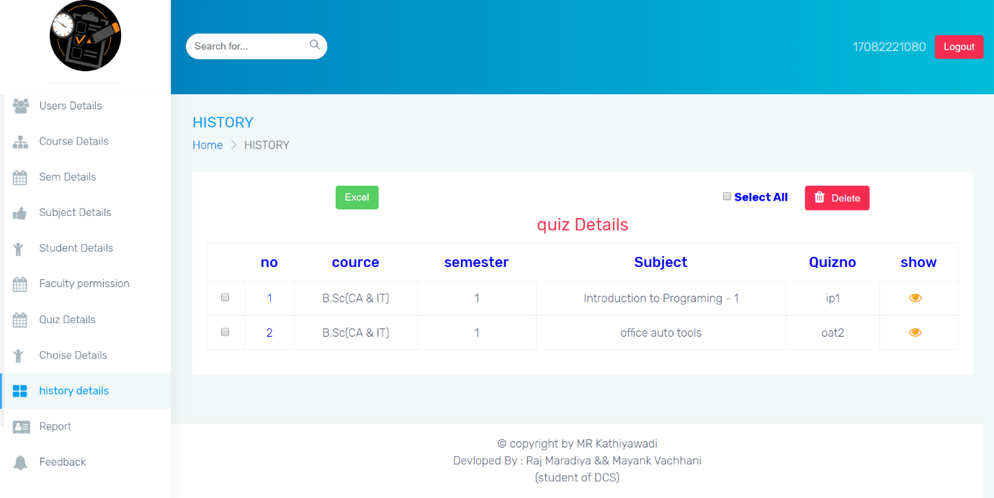

Description:-This page is display history details.

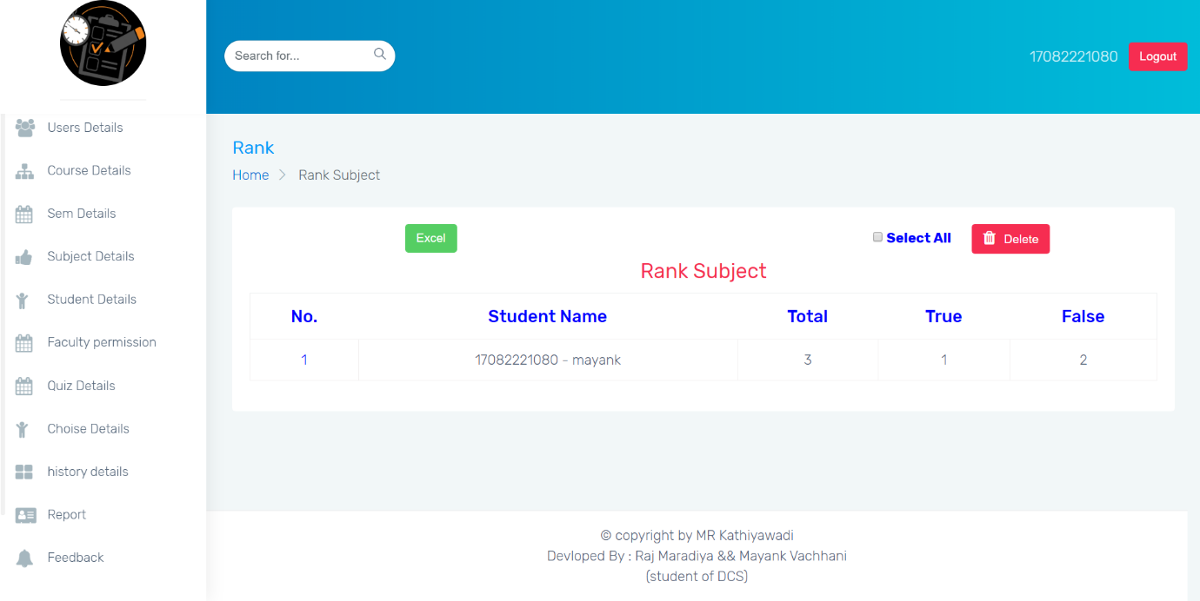

Description:-This page is display students history details.

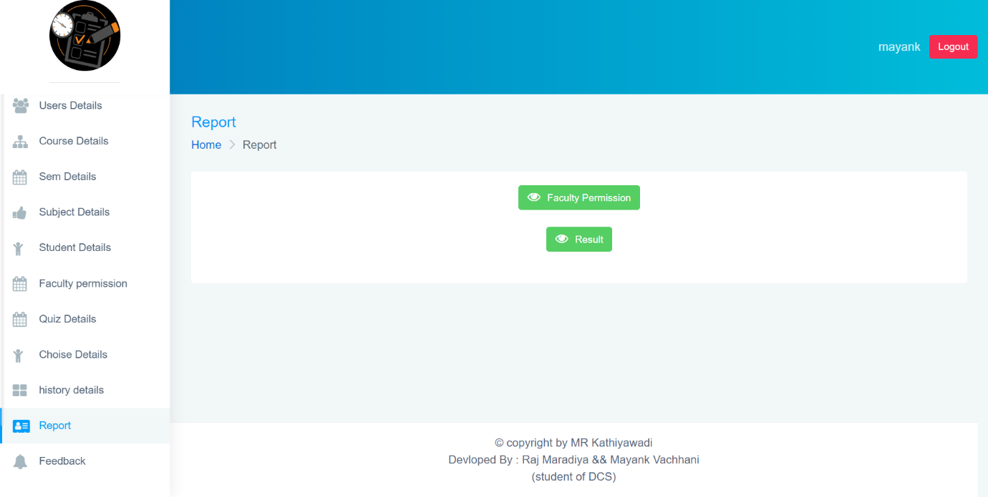

Description:-This page is display report.

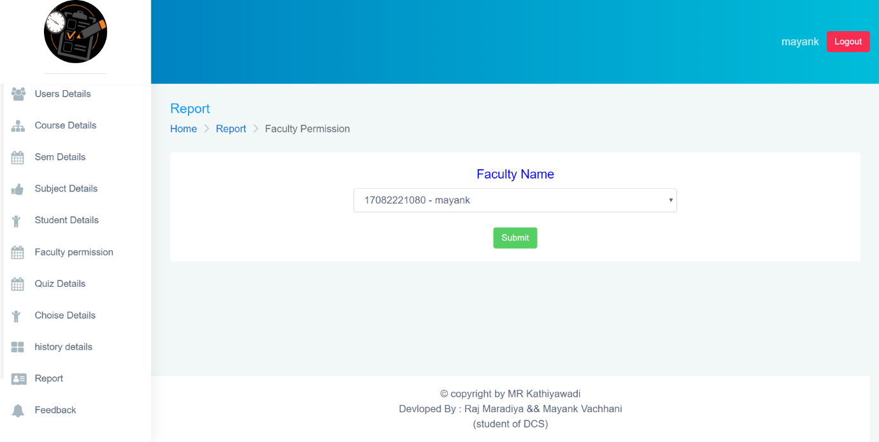

Description:-This page is select faculty name for report.

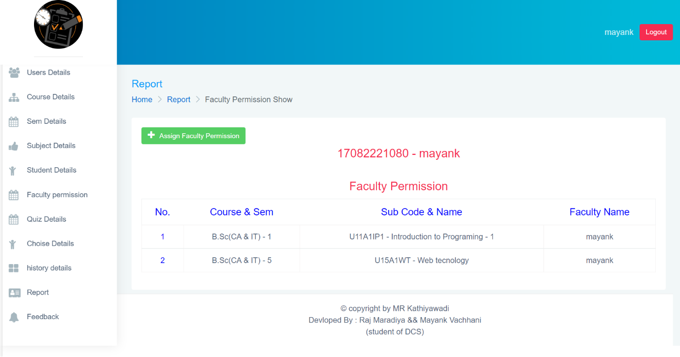

Description:-This page is display report of faculty permission.

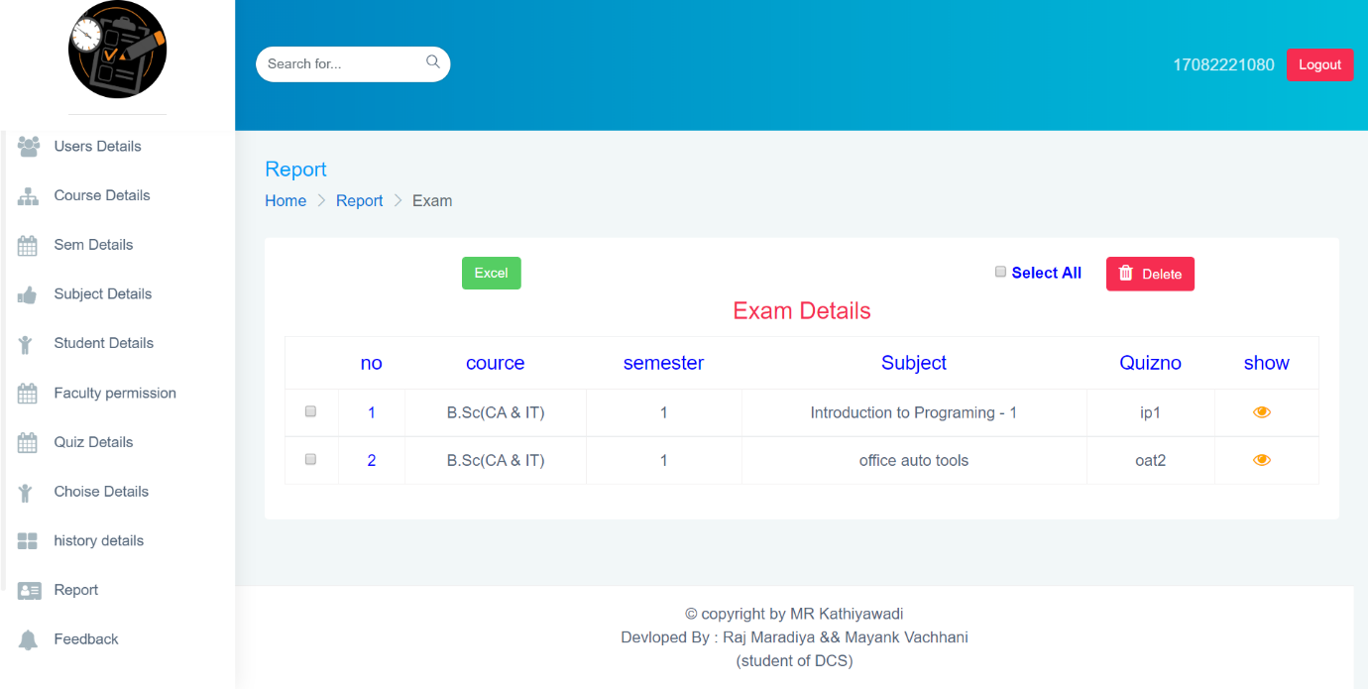

Description:-This page is display report of exam details for result.

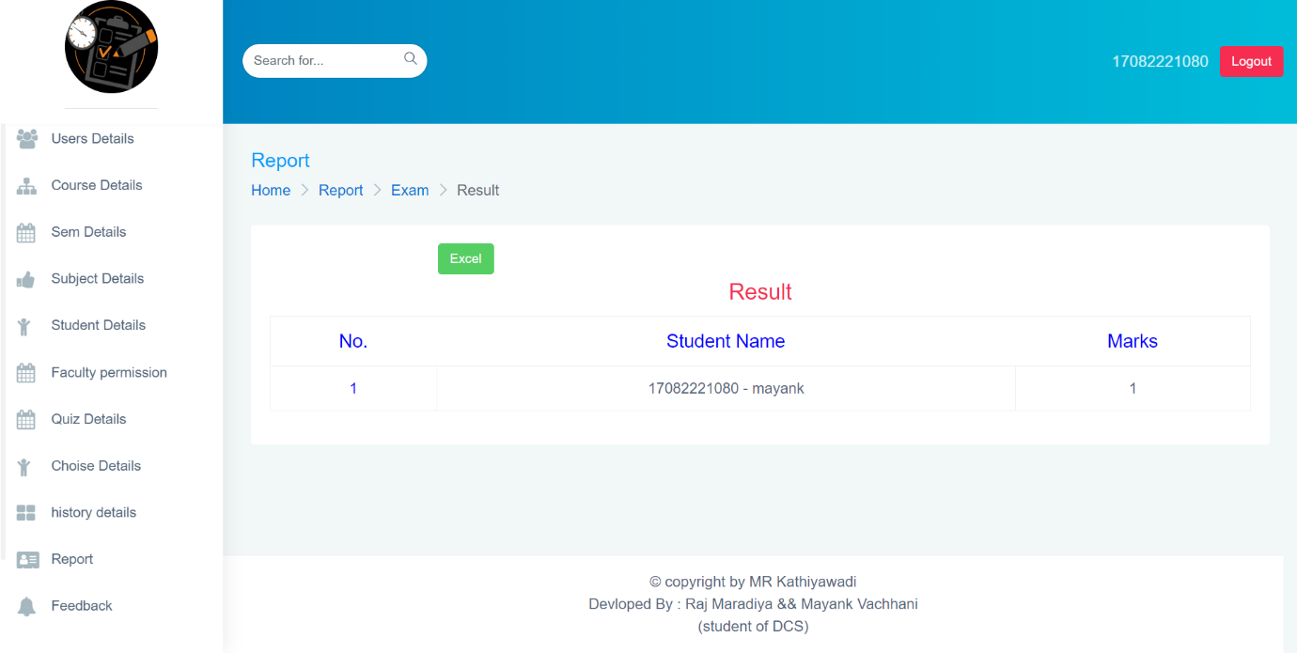

Description:-This page is display report of quiz result.

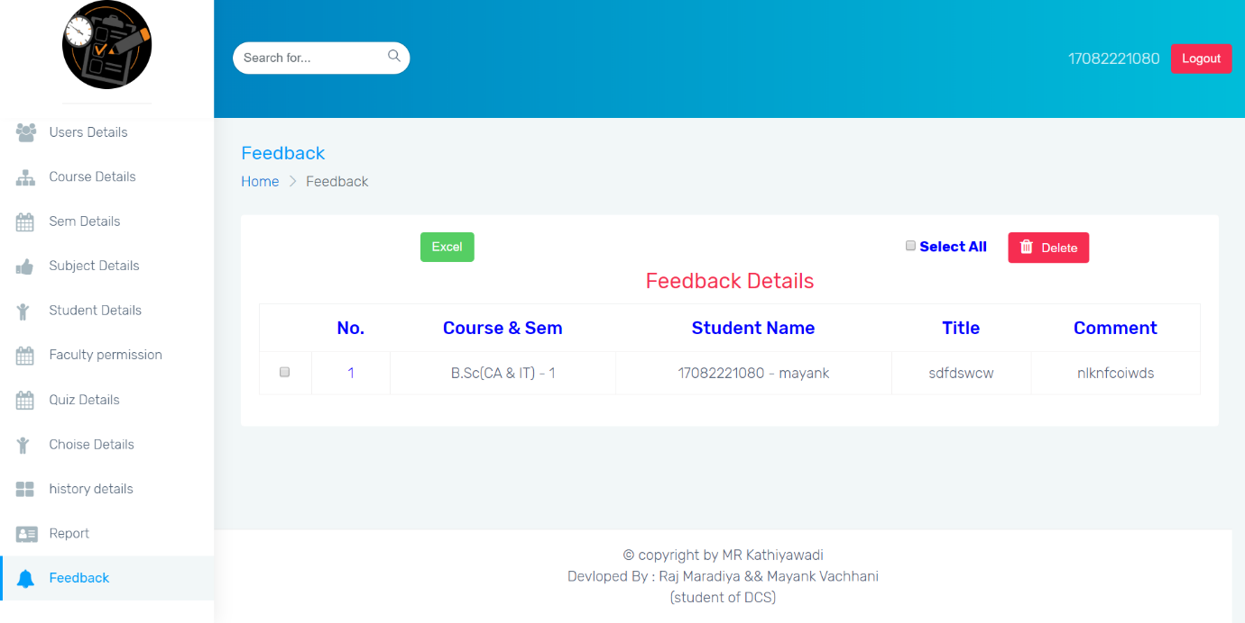

Description:-This page is display feedback details.

USER SIDE

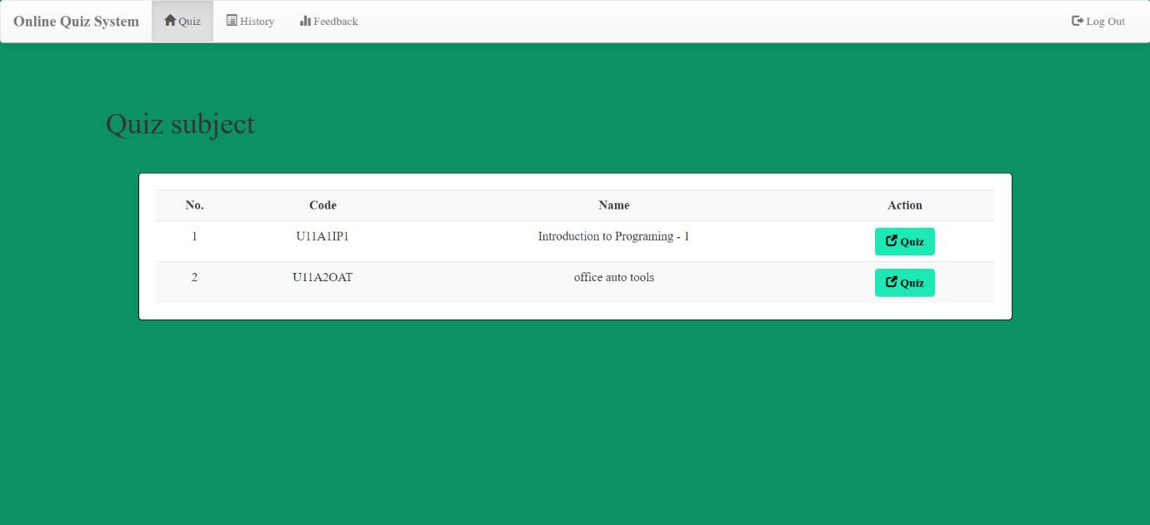

Description:-This page is display quiz subject details.

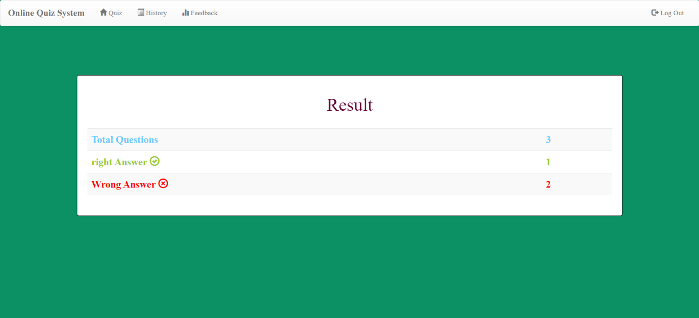

Description:-This page is display quiz result details.

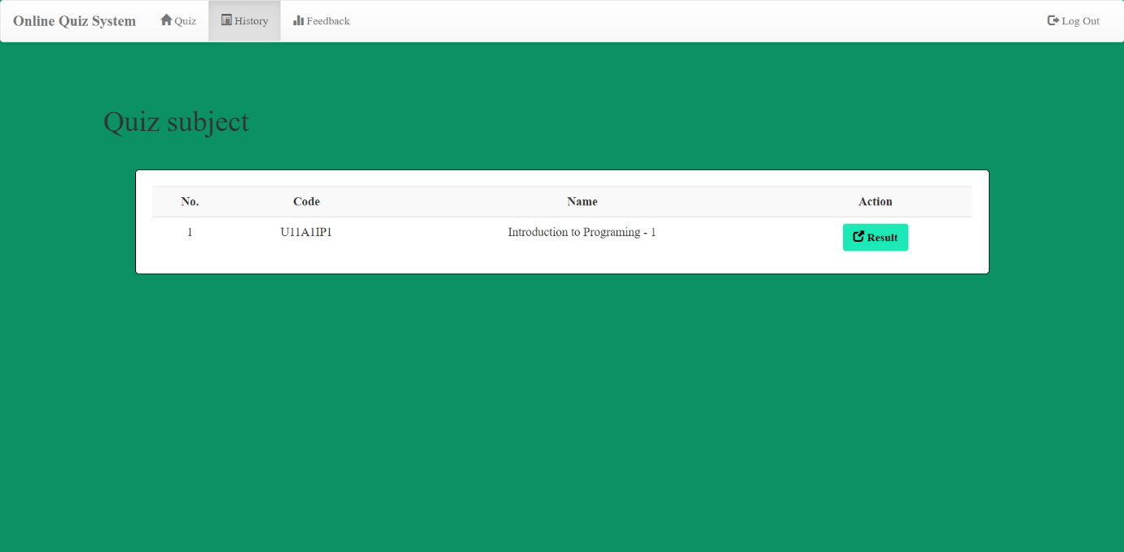

Description:-This page is display history details.

**Testing**

|  |  |  |  |  |
| --- | --- | --- | --- | --- |
| Sr No. | Test Case | Input | Result | Status (Pass/Fail) |
| 1 | Not Null (Required Field Validation) | Tried to keep it blank | Display Notification message | Pass |
| 2 | Range Validator | A value out of range | Display Notification Message | Pass |
| 3 | Only Digits are valid as data entry | Character entry | Display Notification Message | Pass |
| 4 | Email format  (Regular Expression validator) | Email Without ‘@’ | Display error message | Pass |
| 5 | Searching validation | Searched data is not in database | Display  Data not found | Pass |
| 6 | Compare | Input data is different from database | Display error message | Pass |

**Future Enhancement**

* In future update we will add direct email conformation for the result.
* Mobile Notification.
* Time duration.

**Bibliography**

**Books and Websites:**

* **Books:**
* PHP: The Complete Reference 1st Edition

* **Websites:**
* [www.w3schools.com](http://www.w3schools.com)
* [www.sitepoint.com](http://www.sitepoint.com)
* [www.tutorialspoint.com](http://www.tutorialspoint.com)
* <https://stackoverflow.com>